**Version Control System**

1. Create a html file at local drive to push on Github.

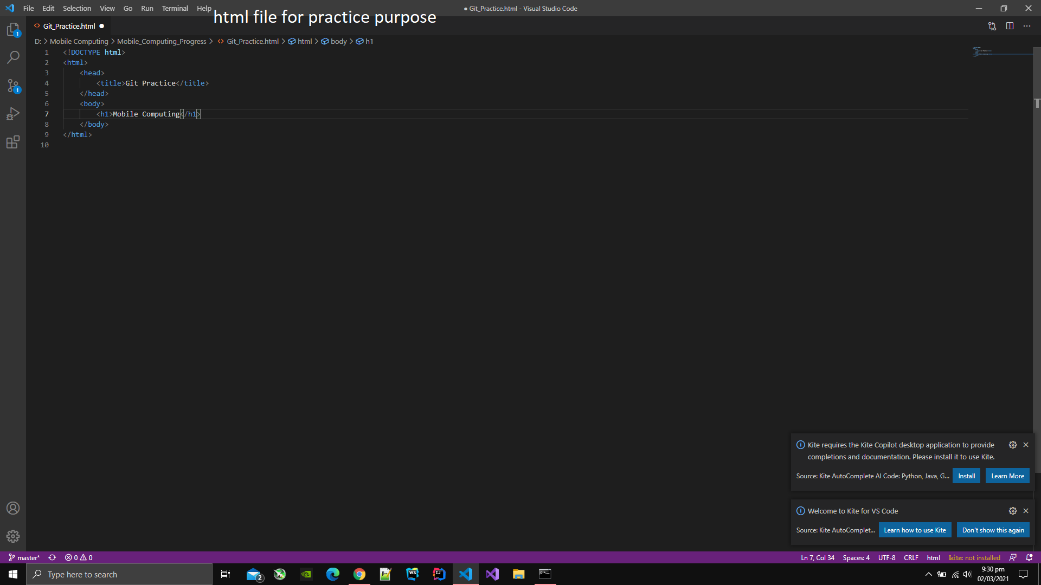

1. Open command line.
2. Move to the the directory where html file is created.
3. Type git clone [url of repository ].

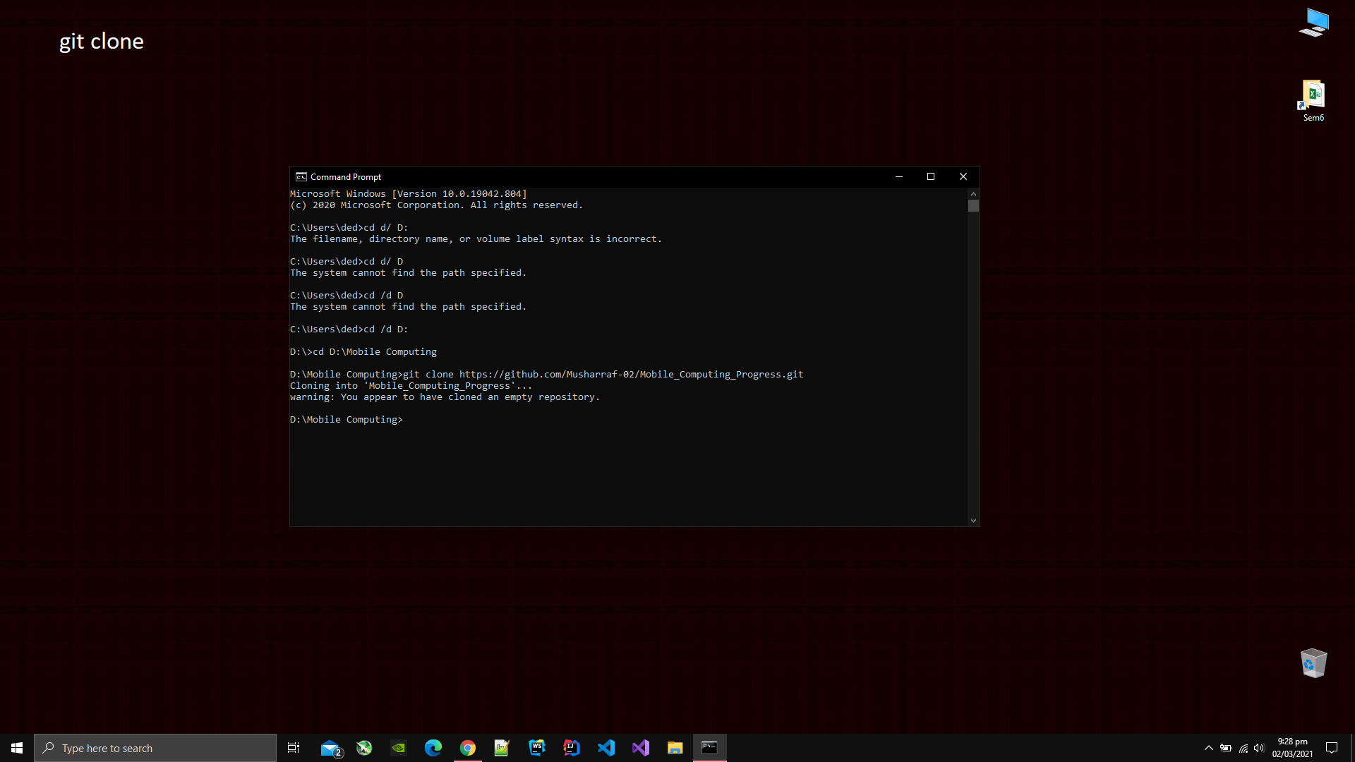

1. Type git add [name of file or folder] to add that file or folder on the git hub.

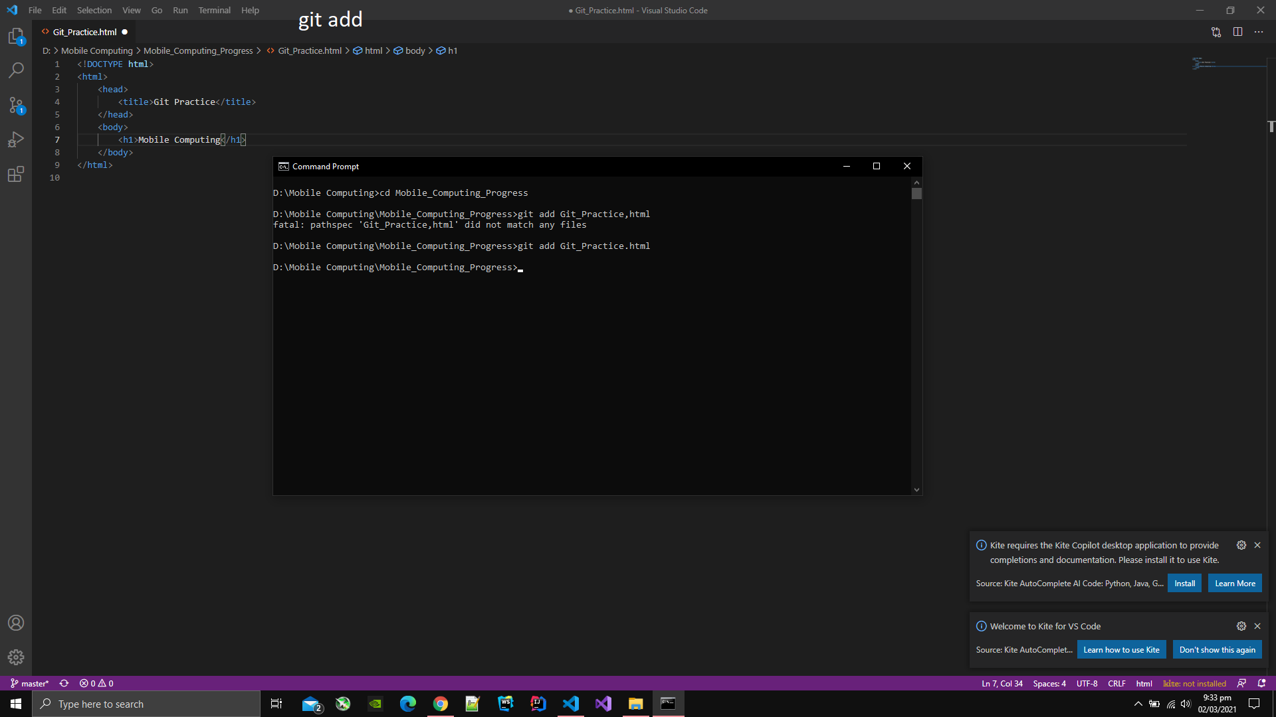

1. Type git commit -m [message for the commit].

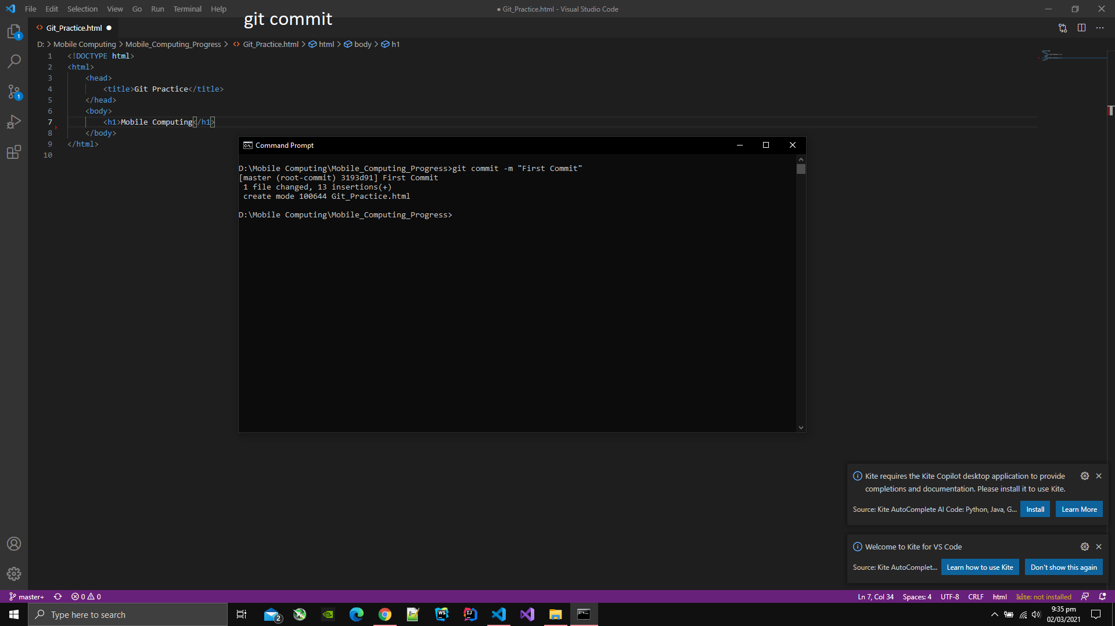

1. Type git push to push the file or directory on the Github repository that was added.

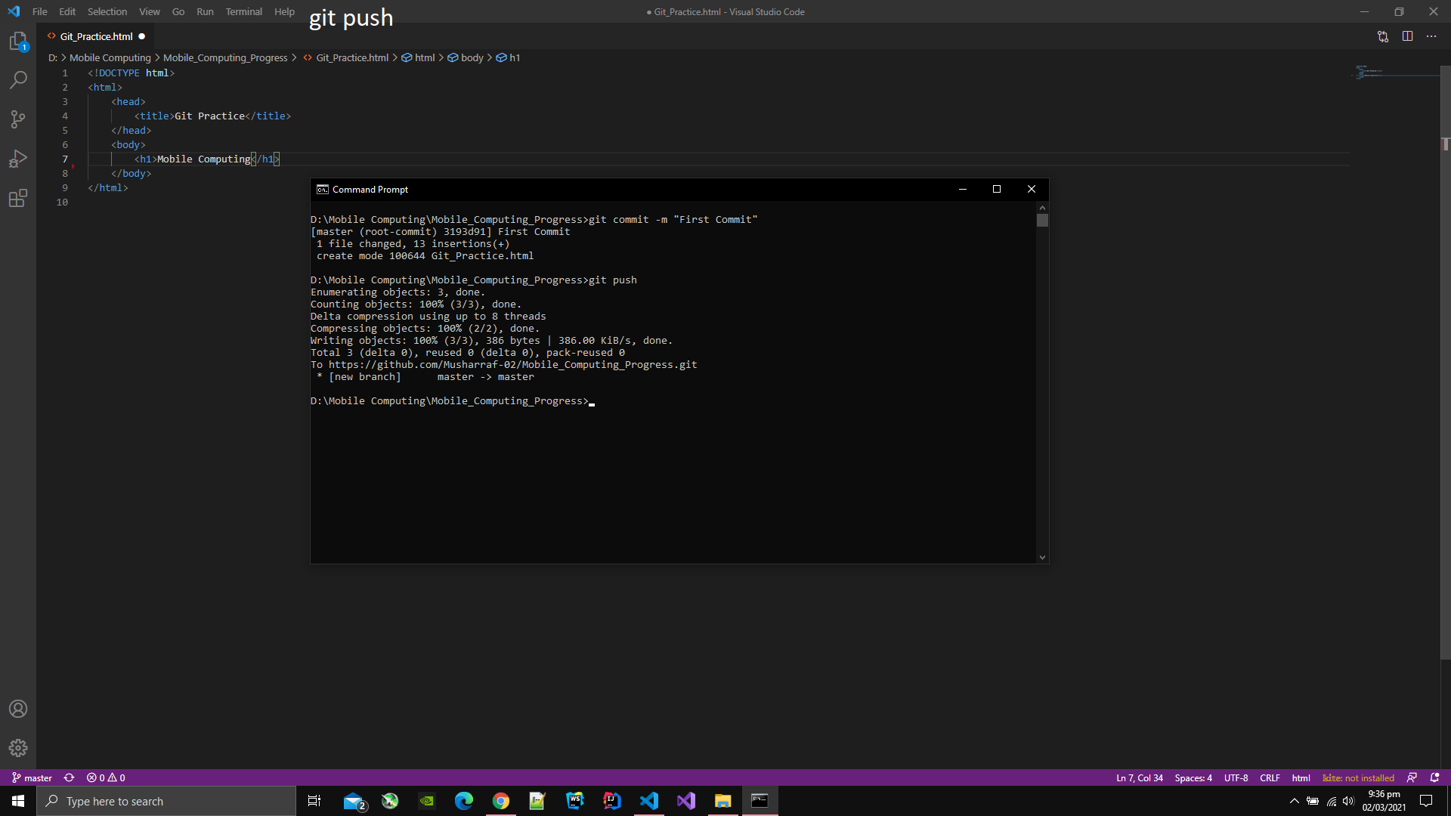

1. You can see the message on the site that was typed in the command git commit -m [message].

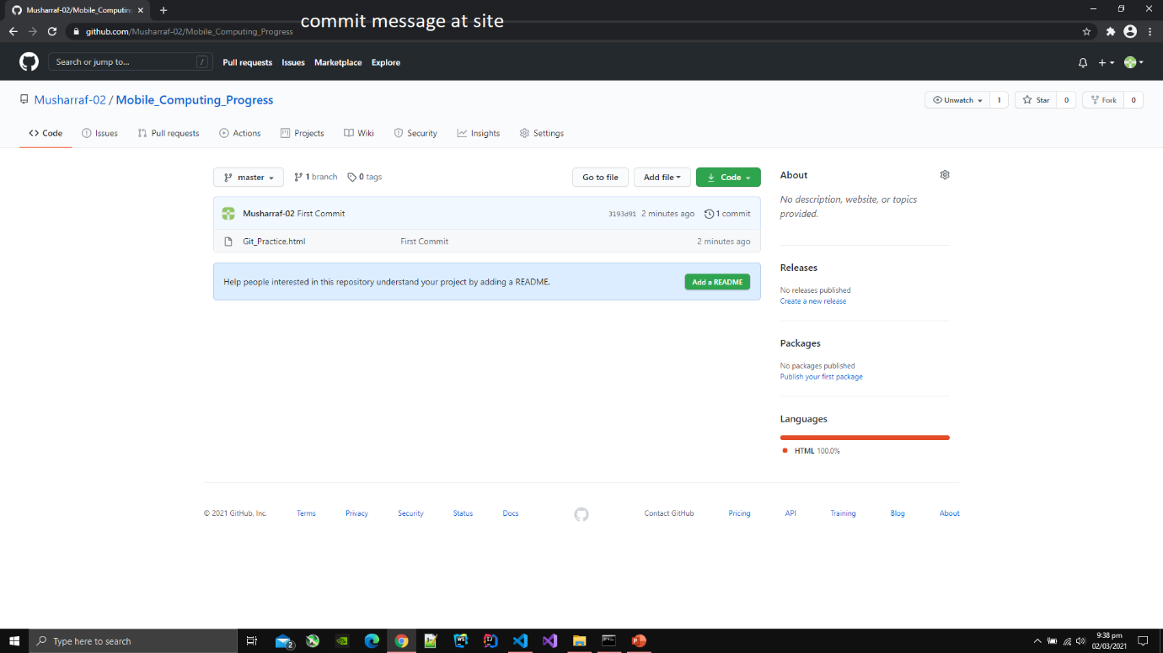

1. You can also see the content of file at Github via clicking on the file.

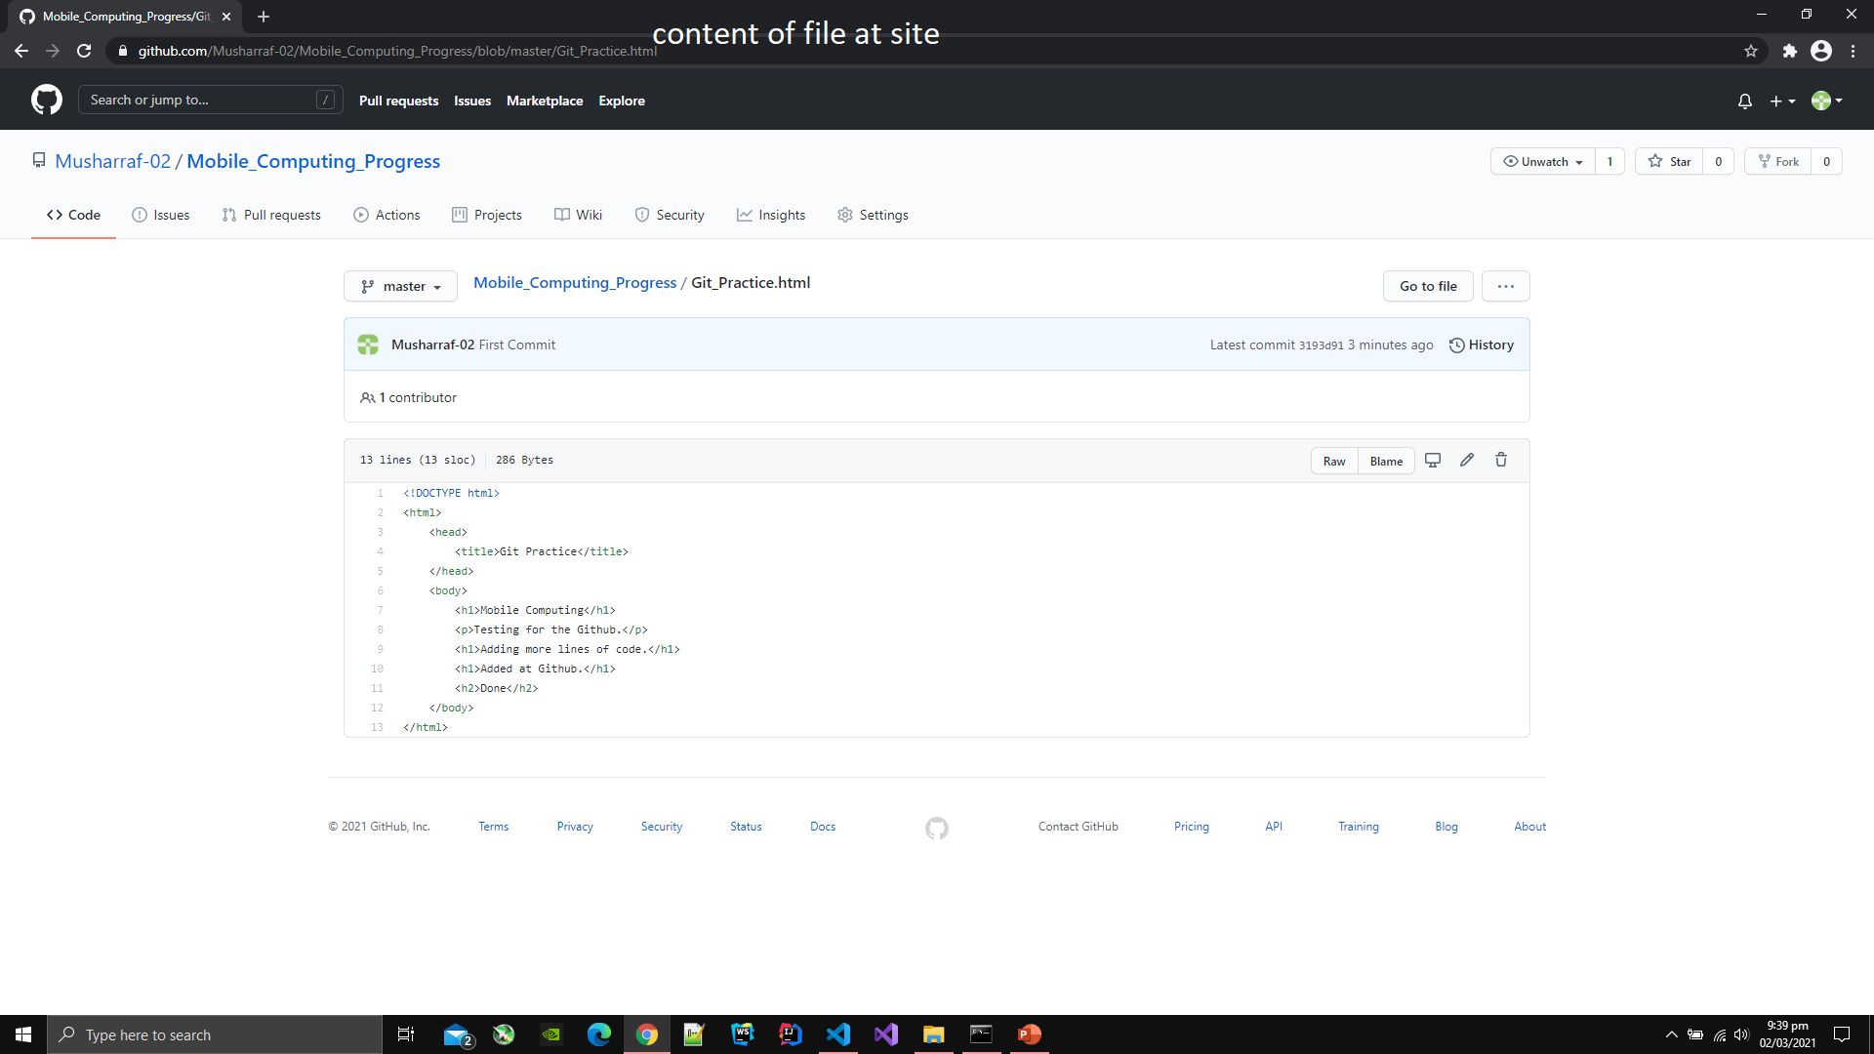

1. Now changing file content at editor.

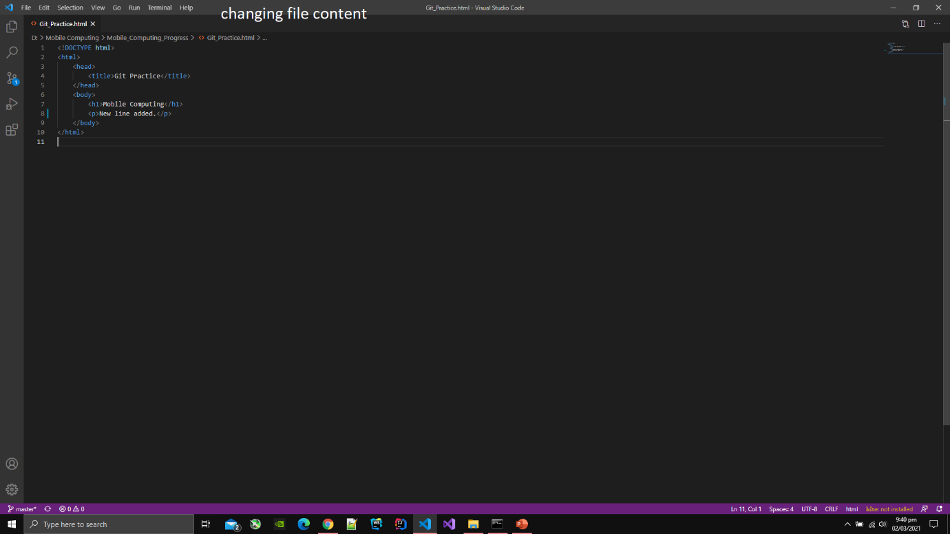

1. Again adding the file and commiting at the same time by typing command git commit -am [message].

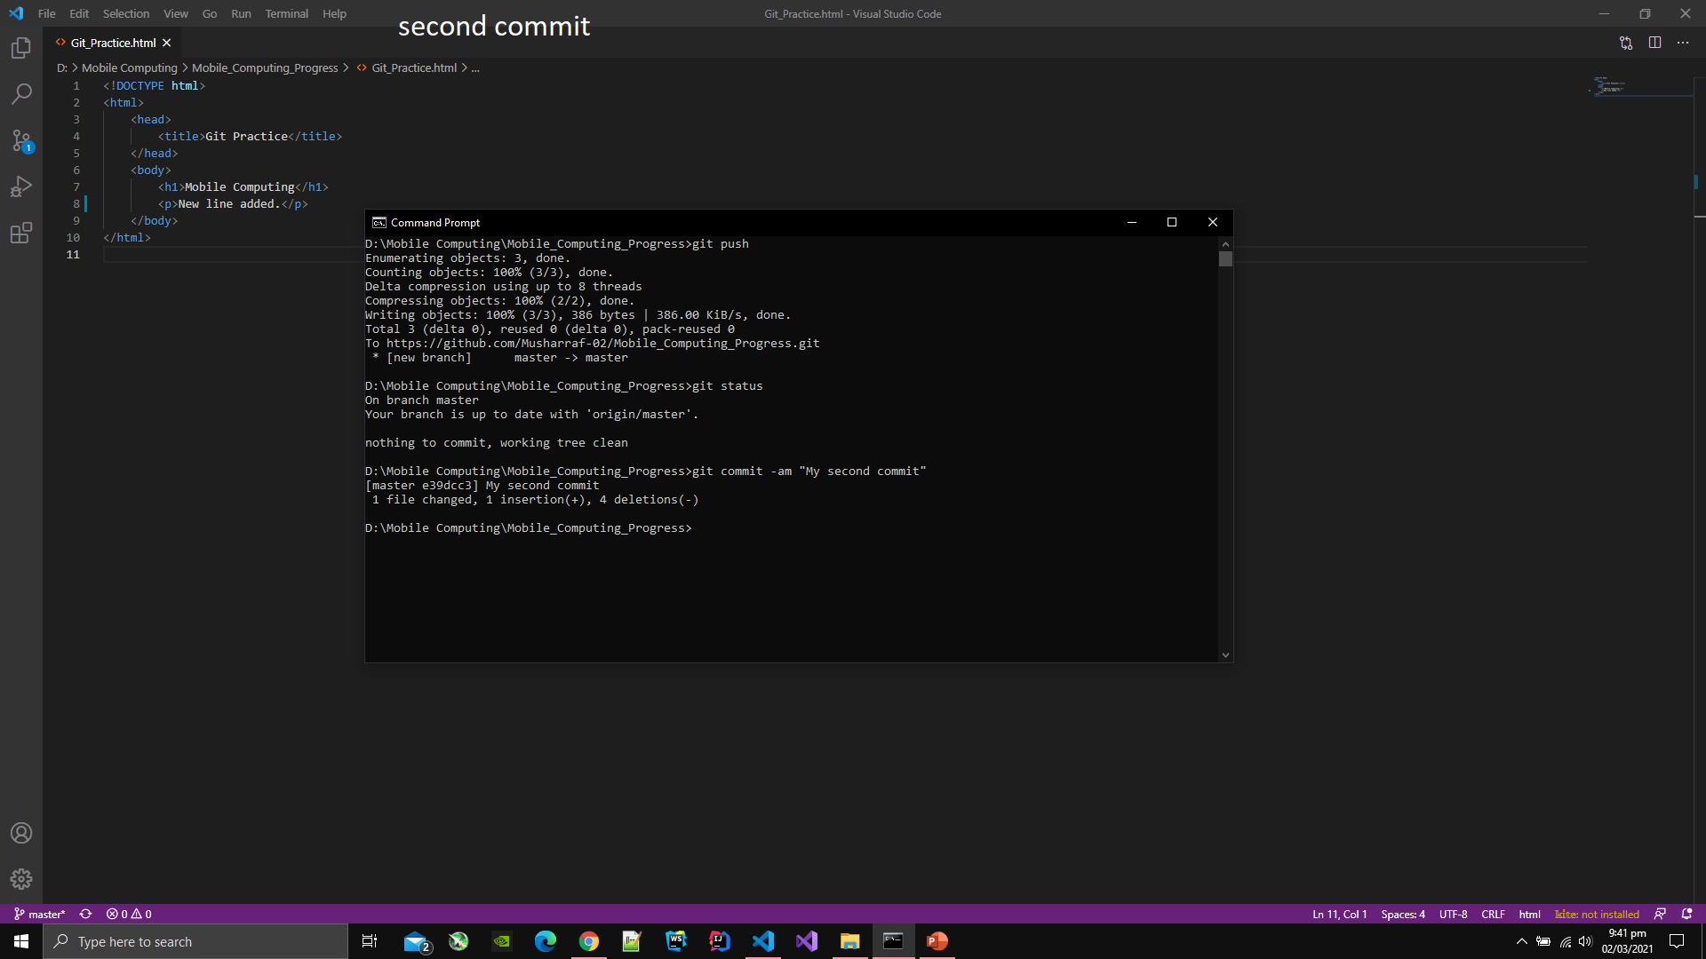

1. Type git push to add the file or directory on Github that was added before.

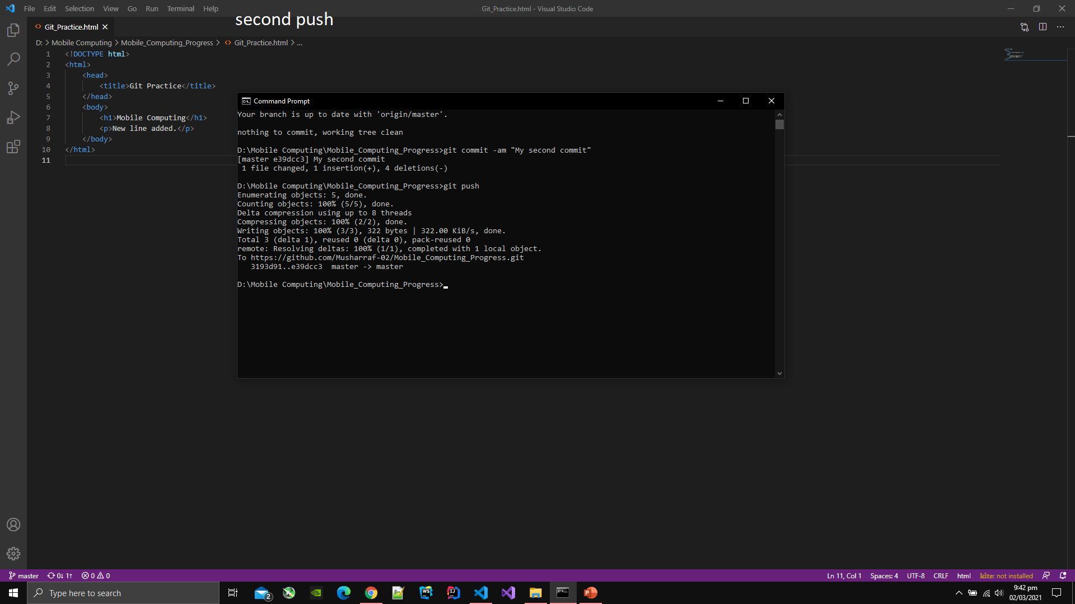

1. You can see the status of branch via typing git status.

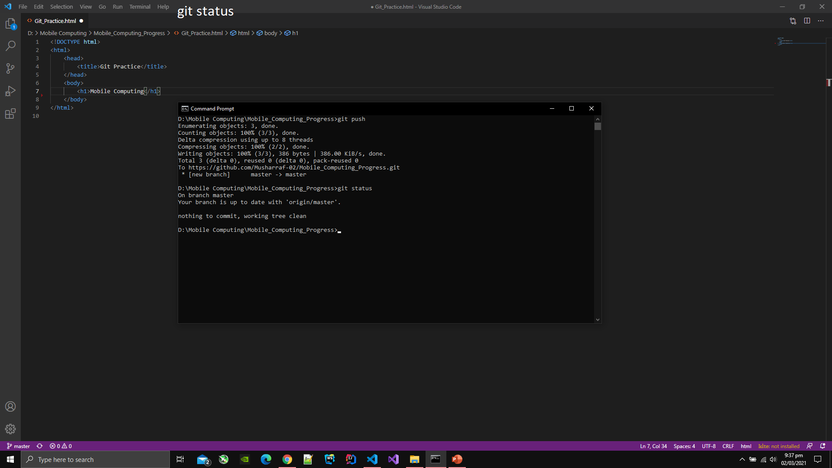

1. You can see the message at the site that was typed in the commit command.

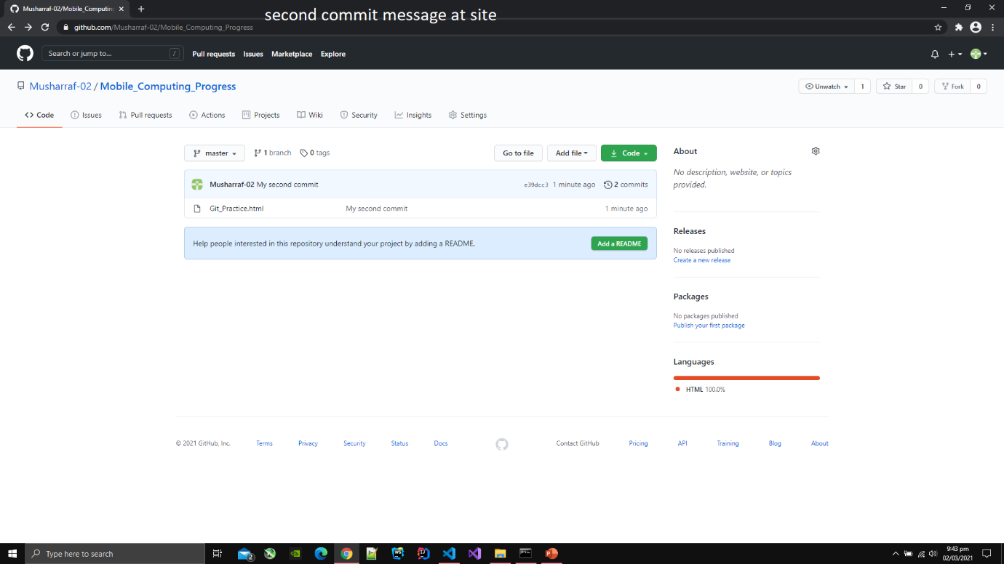

1. You can also change the content of file at the Github site.
2. Click on the pencil icon then the file will open in the online editor.
3. Then you can edit the content of file at the site.

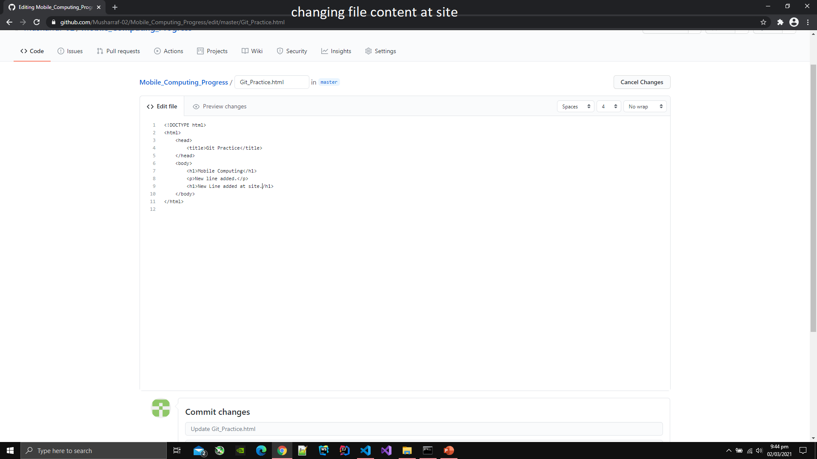

1. After editing file at the site you have to commit changes at the site.
2. To commit changes at the site press the button Commit Changes.

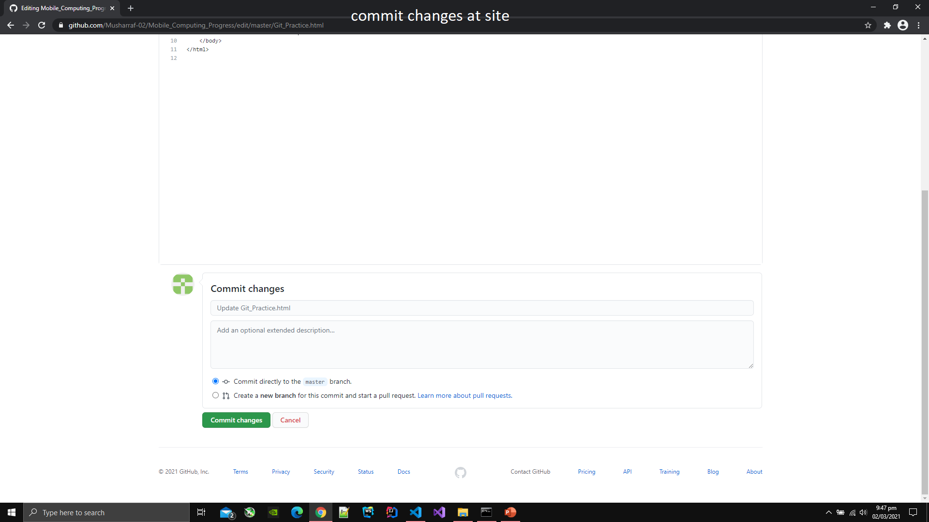

1. After pressing the button you can see the commit message as Update [file name].

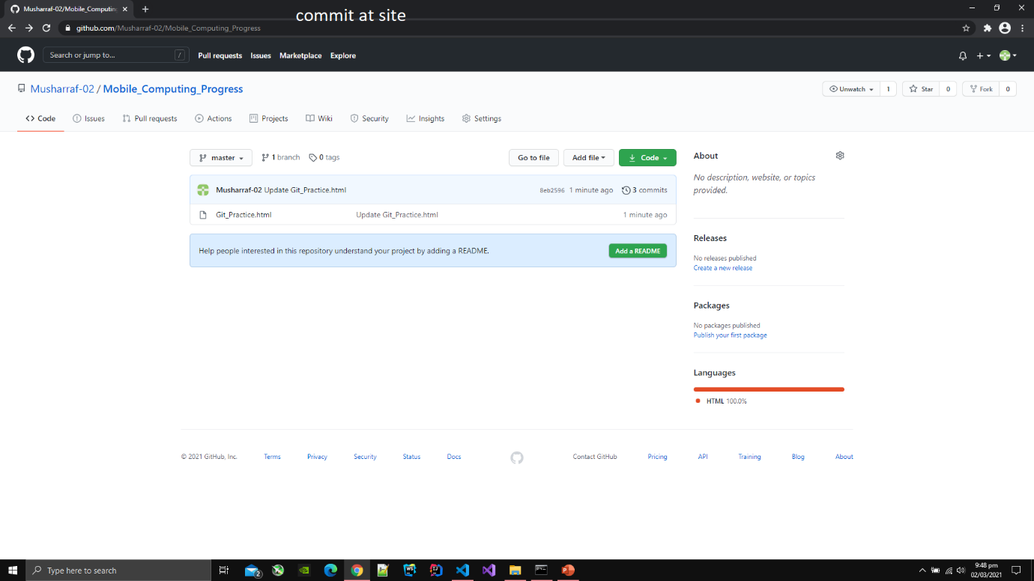

1. You can also see the version hierarchy at the site.
2. Click on the number like e39cc3 that is assinged by Github than all the changes that were made will be highlighted.

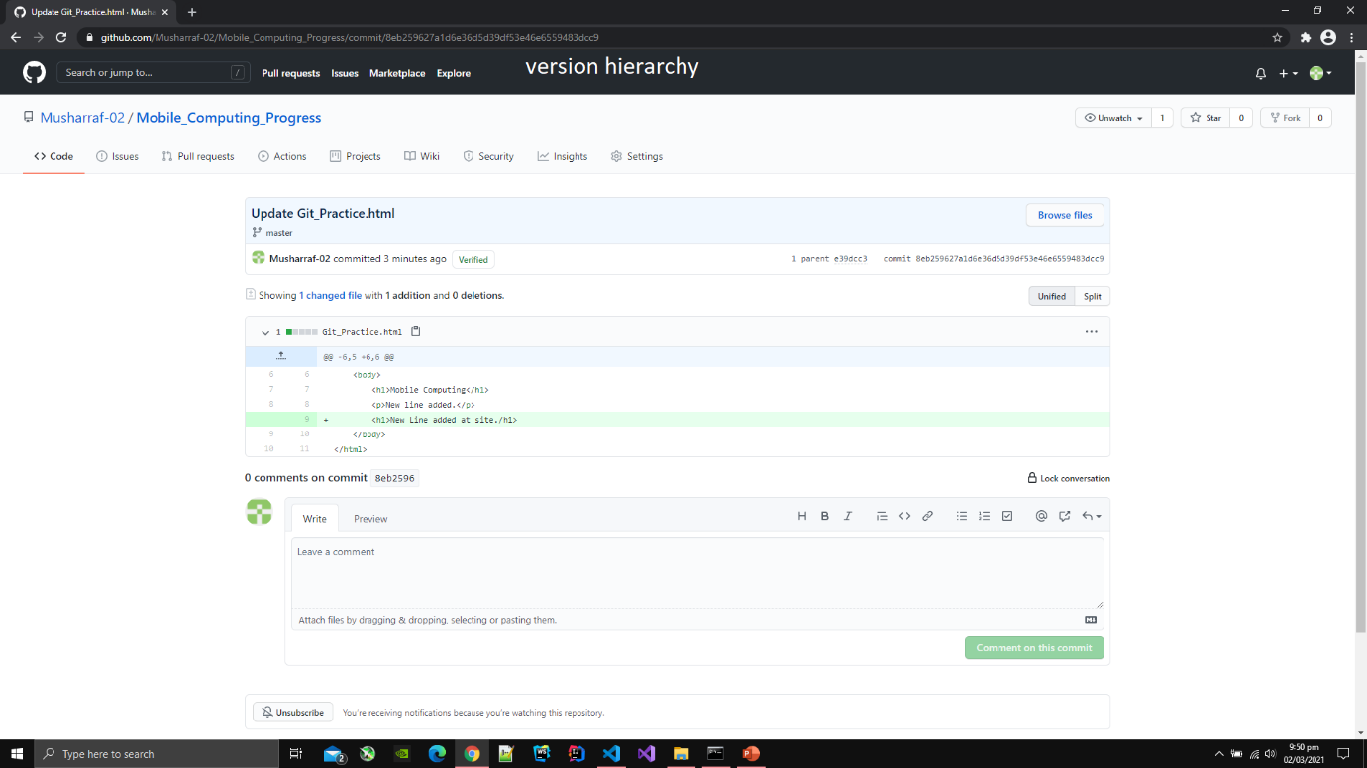

1. To get the data from the Github repository type git pull in the command line
2. After typing the data will br downloaded at the specified directory.

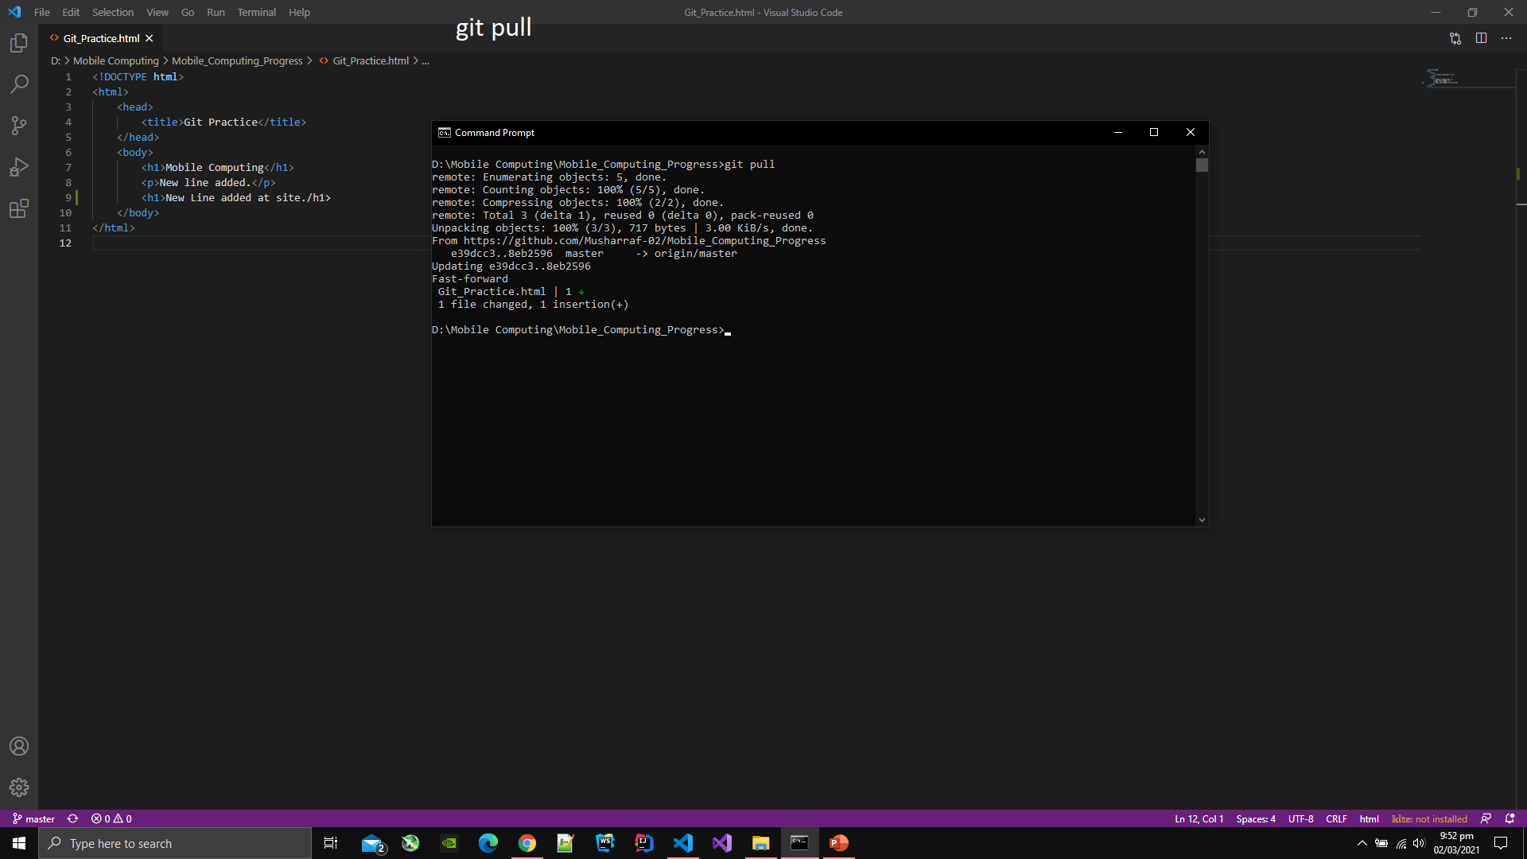

1. Merge Conflict can also occur if you have recently updated file at the site and have not used pull command and then you edit file at the editor and then you add the file and then push the edited file.
2. To solve the merge conflict select the file content form the prompt that is showed in the editor in which file is open.

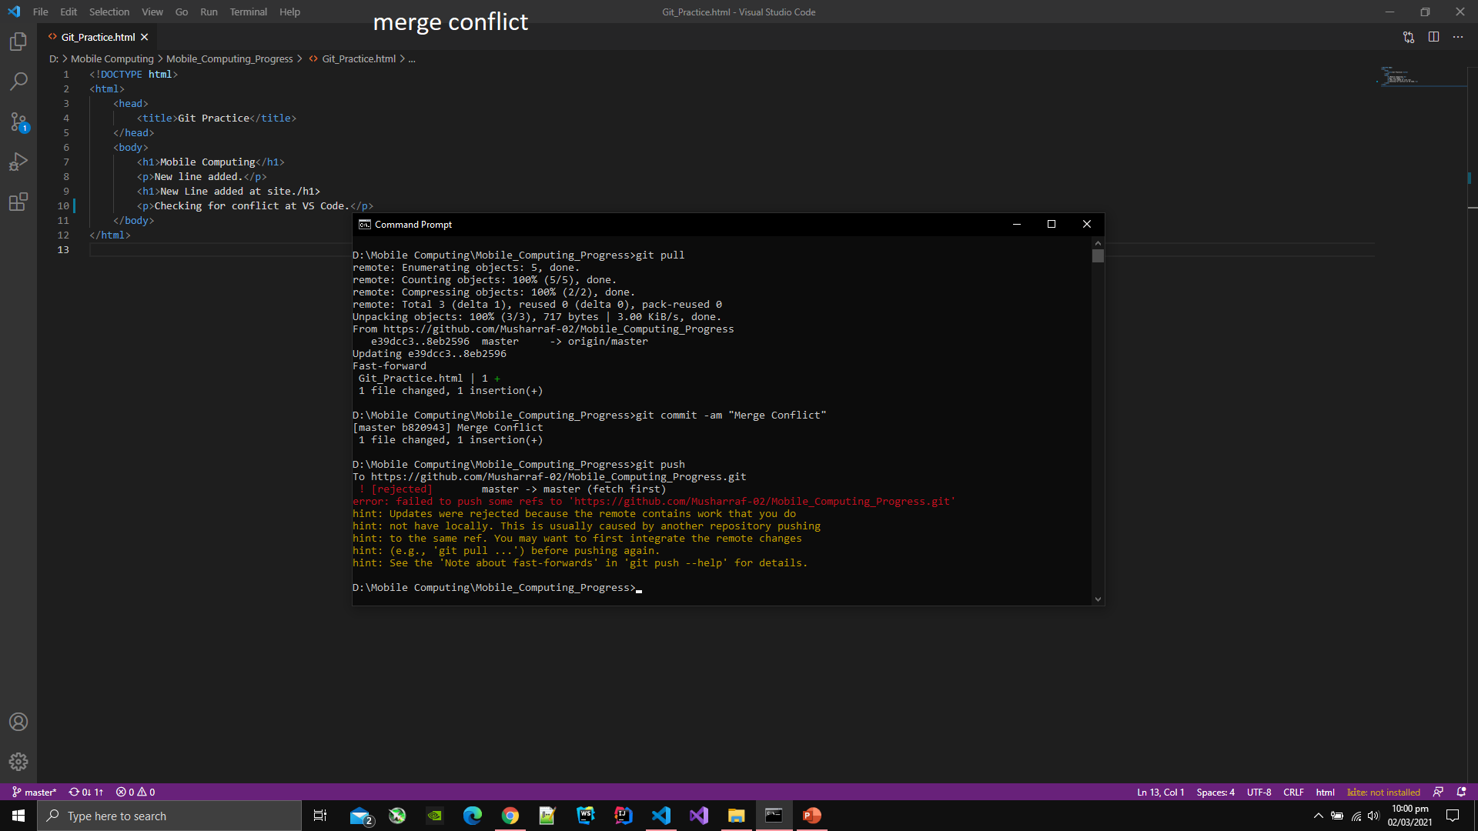

1. To see the log of all the commits and push that were made type git log in the command line then the log will display in command line.

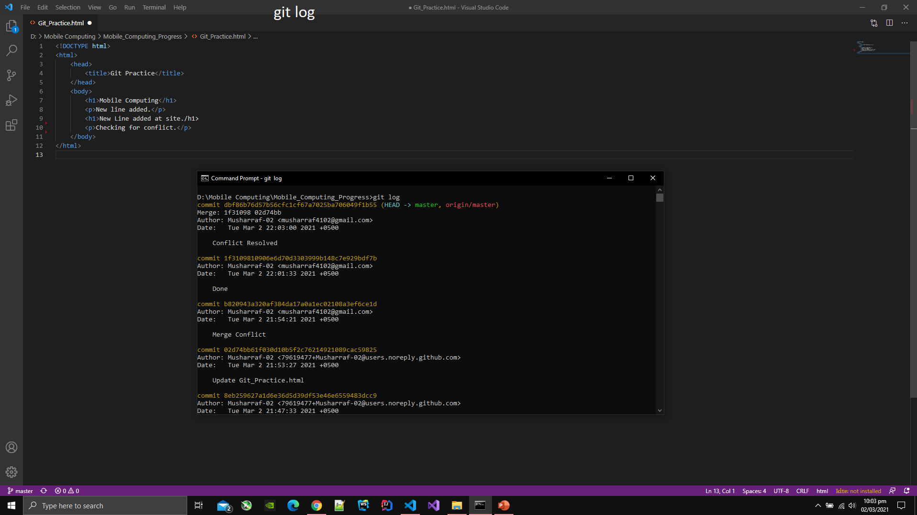

1. Type git branch to see the branch name of project on which you are currently working.

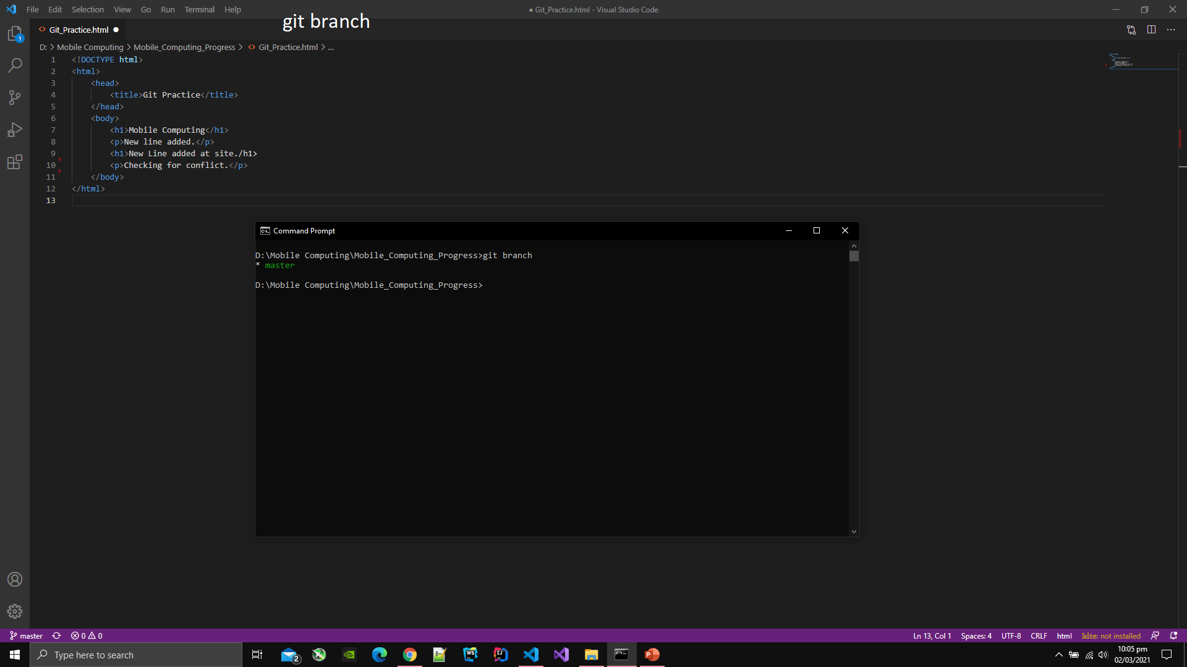

1. Make a branch of currently working project by typing git checkout -b [branch name].
2. After typing above command, the files in the editor will automatilcally switch to the files of new branch.

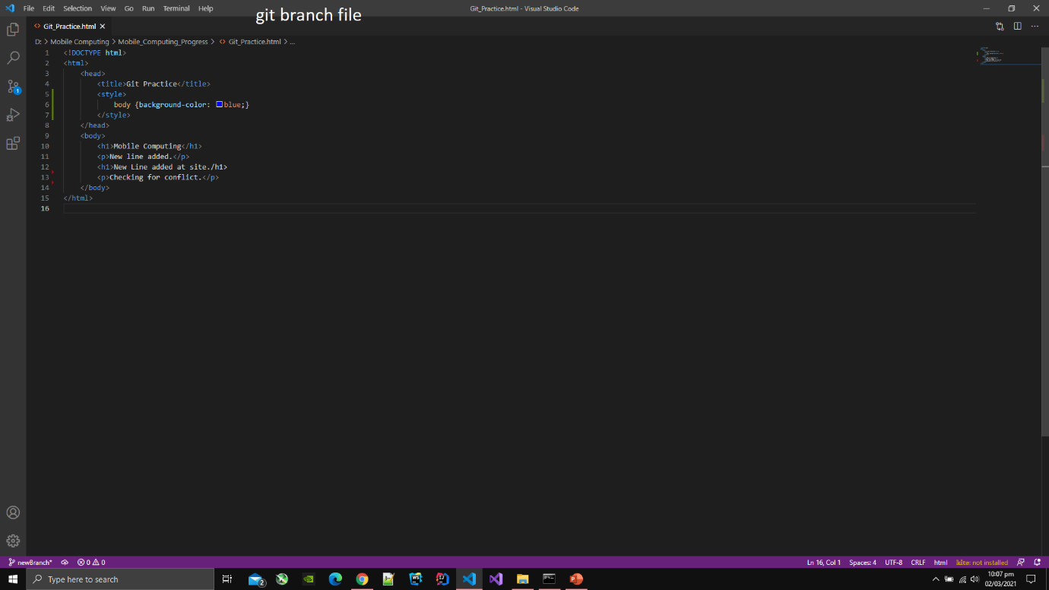

1. To switch back to master branch type git checkout master.
2. All the files in the editor will be switched to the files of master branch after typing the above command.

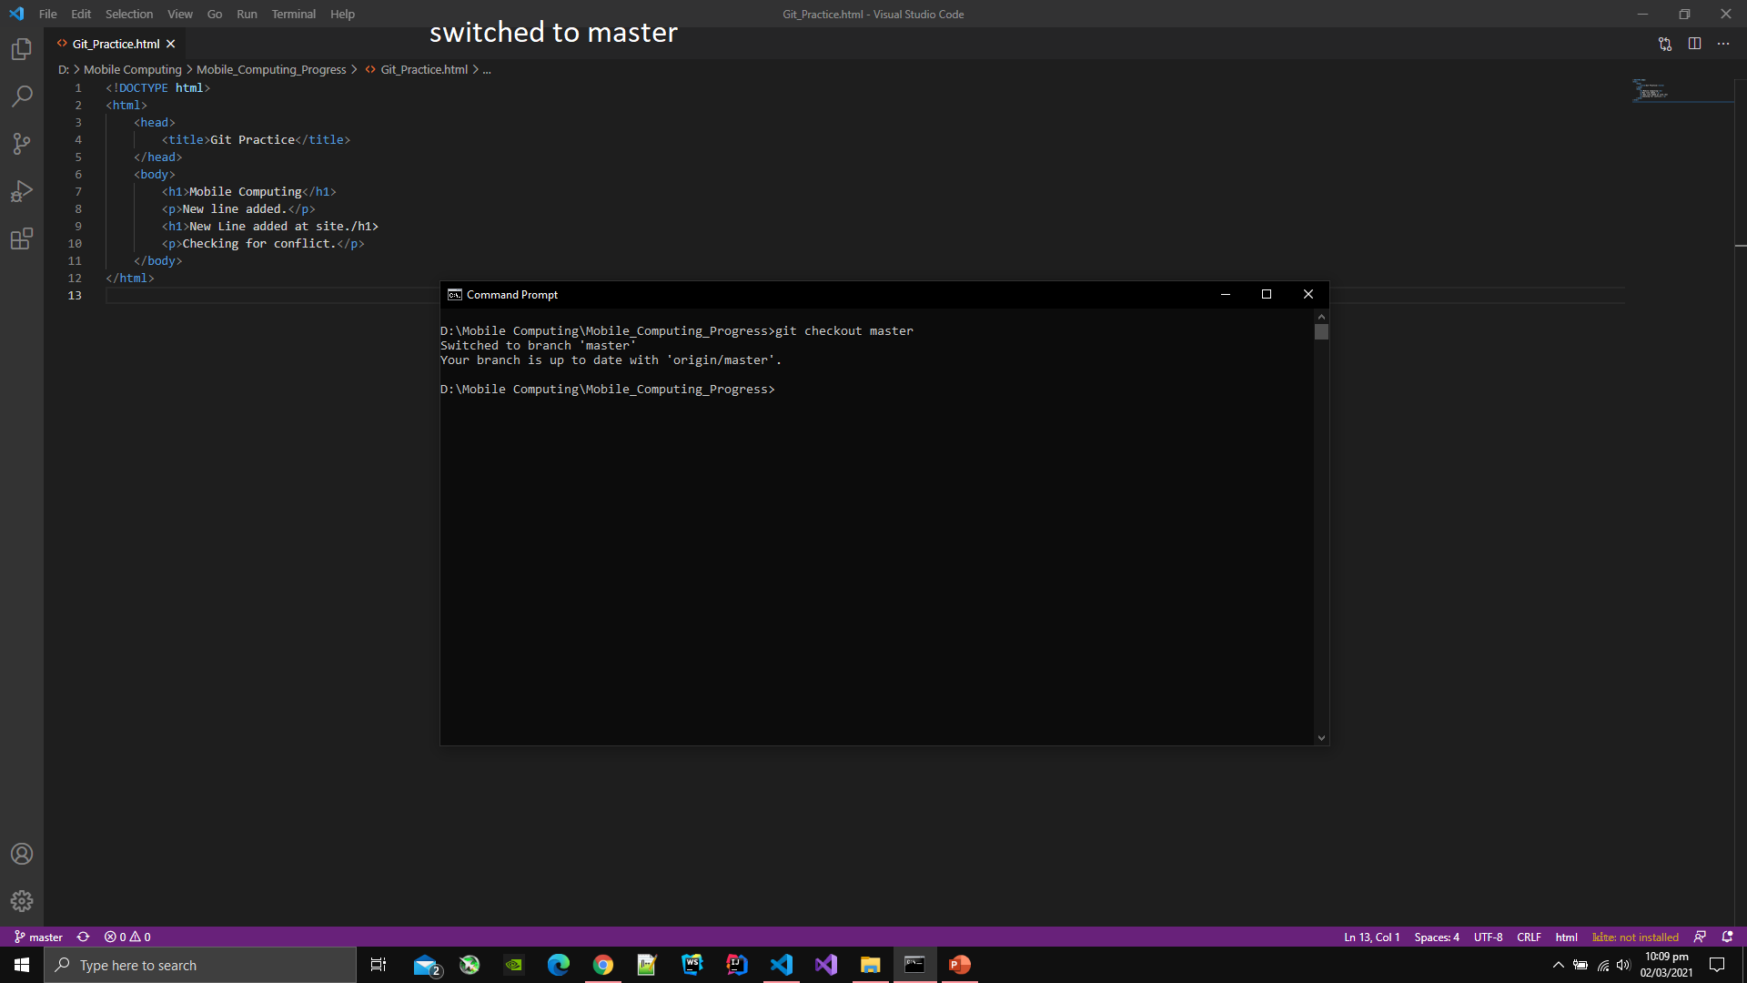

1. Below is the content of master branch file after switching back to master branch.

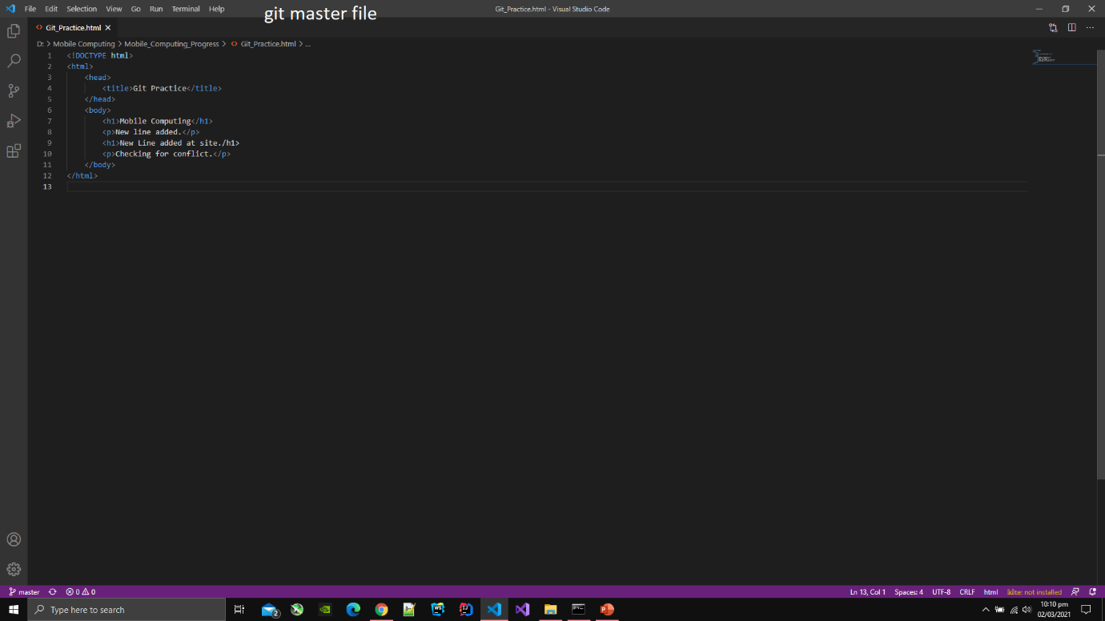

1. After trying new features in the other branch, you can merge the content of new branch and master branch.
2. To merge the content of other branch with master branch type git merge [branch name] in the command line.

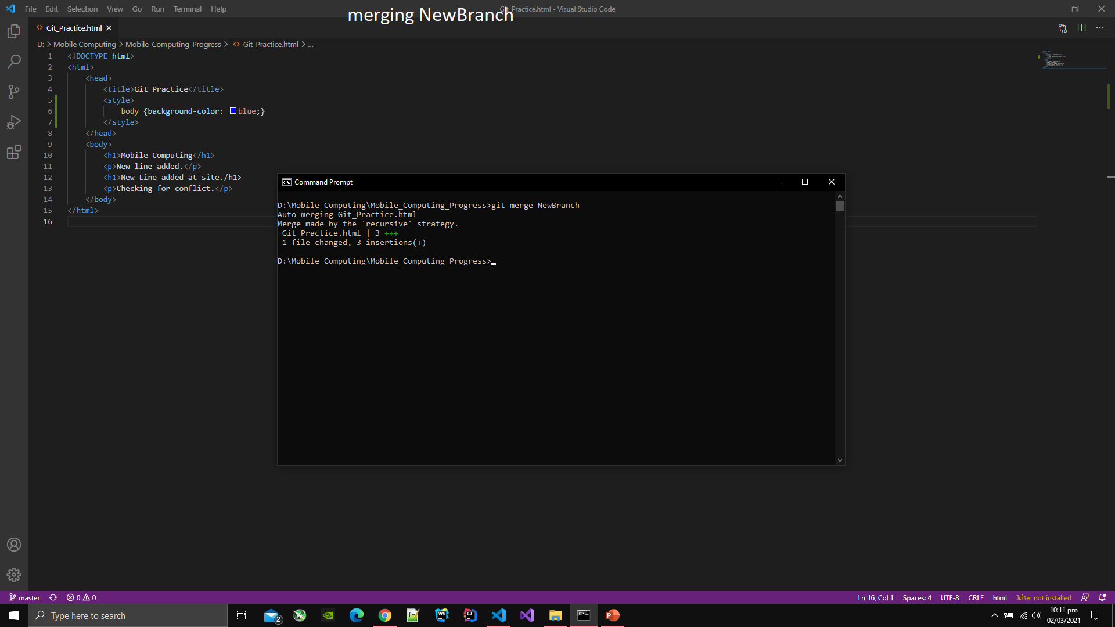

1. After merging the branch with master branch the content of the file will be as follows:

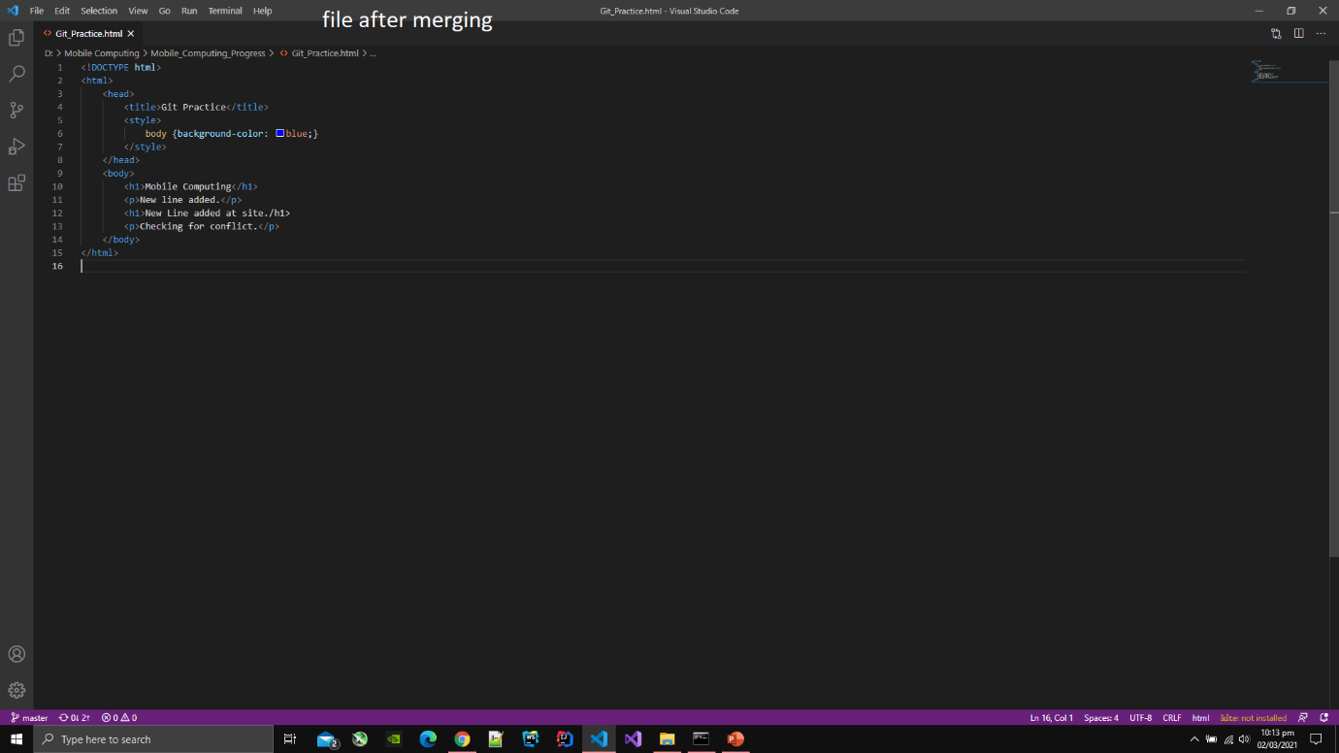

1. To delete the branch type git branch -D [branch name] in the command line.

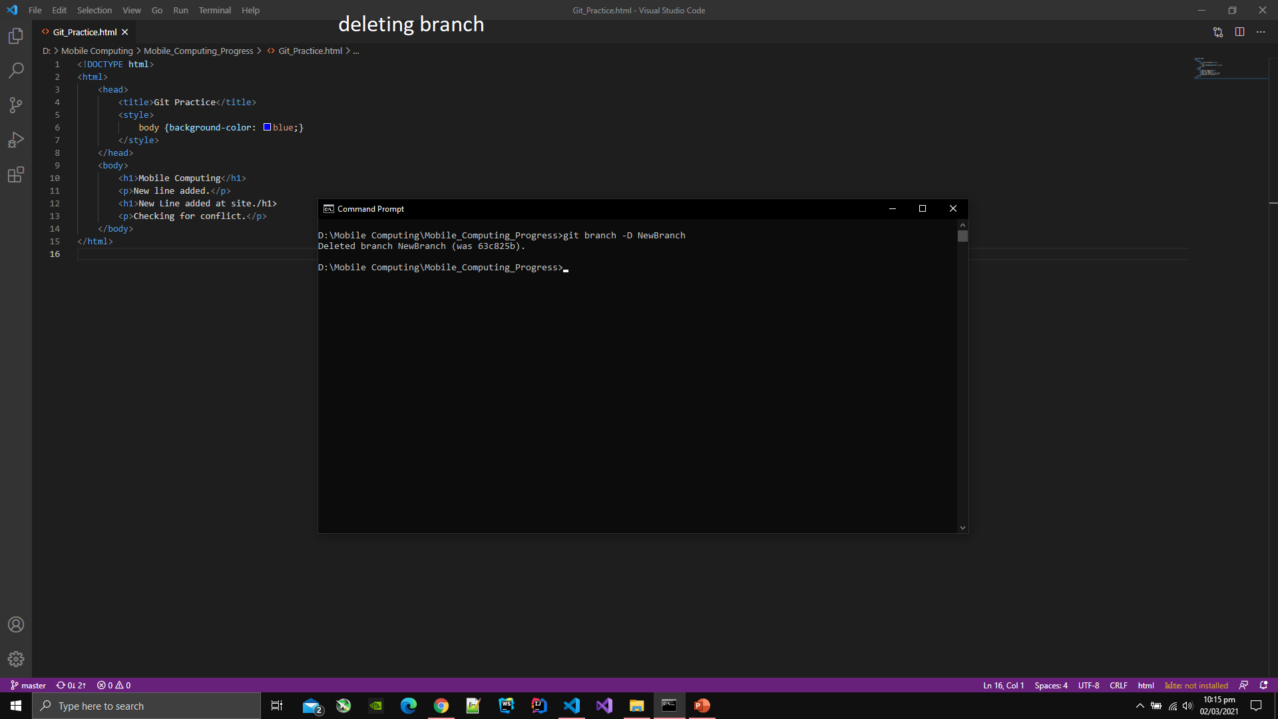

**Android Screens**

1. Download Android Studio.
2. After downlaing Android Studio, open it.
3. Then click on the create new project.
4. Select Empty Activity template from the list of different templates.
5. After selecting template, type the name of project and select directory where you want to create project.
6. After the project is created, go to activity_main.xml and switch to design view.
7. There you can drag and drop different elements and change their attributes like colors, background, gradient, position, font size and many more
8. After creating the screen, select on the play button then select the device where you want to run the project.

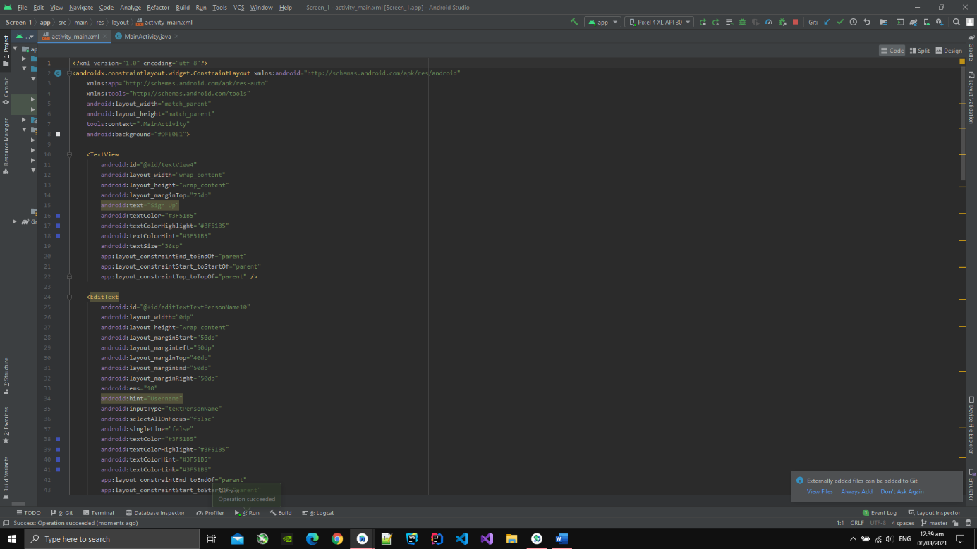

**Screen 1**

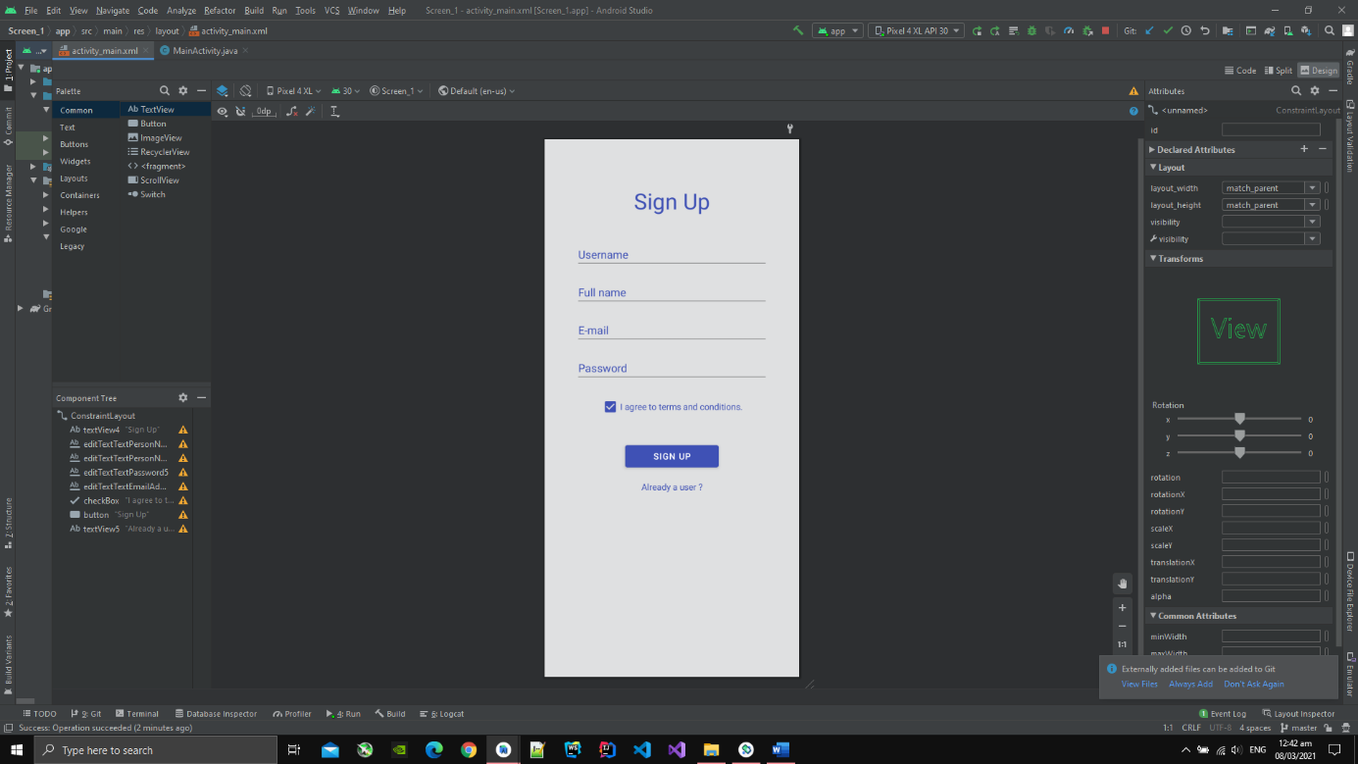

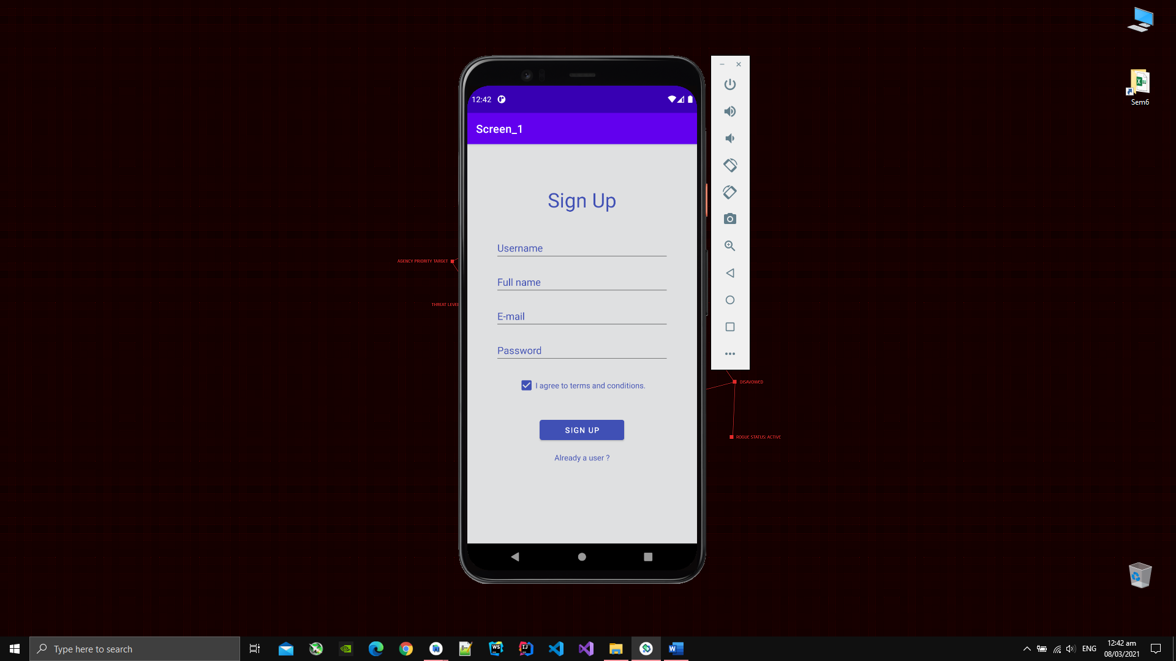

**Screen 2**

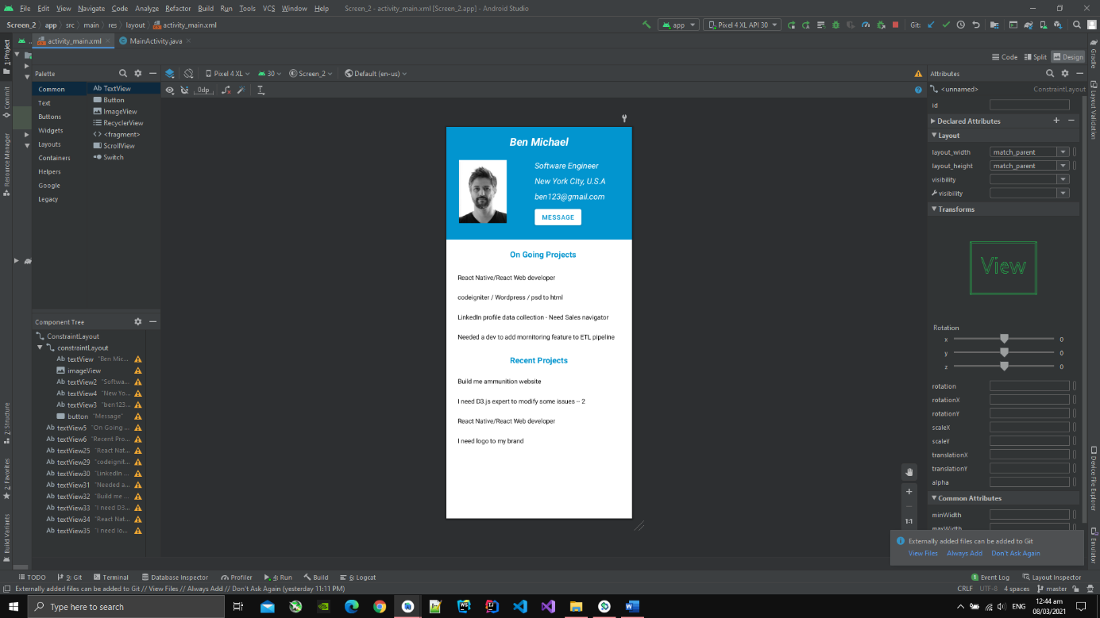

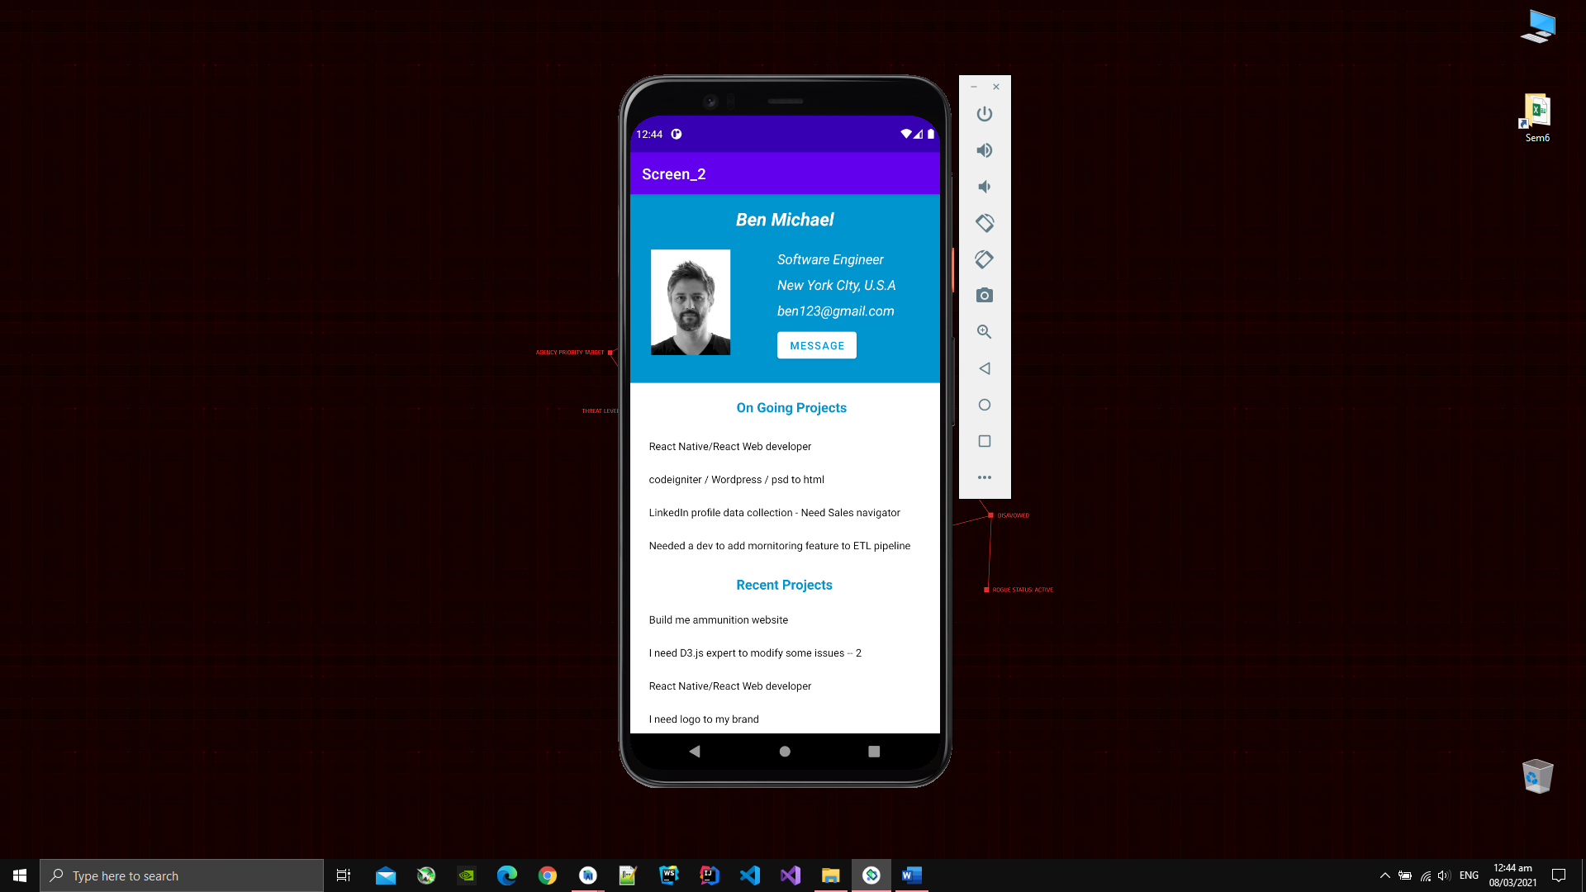

**Screen 3**

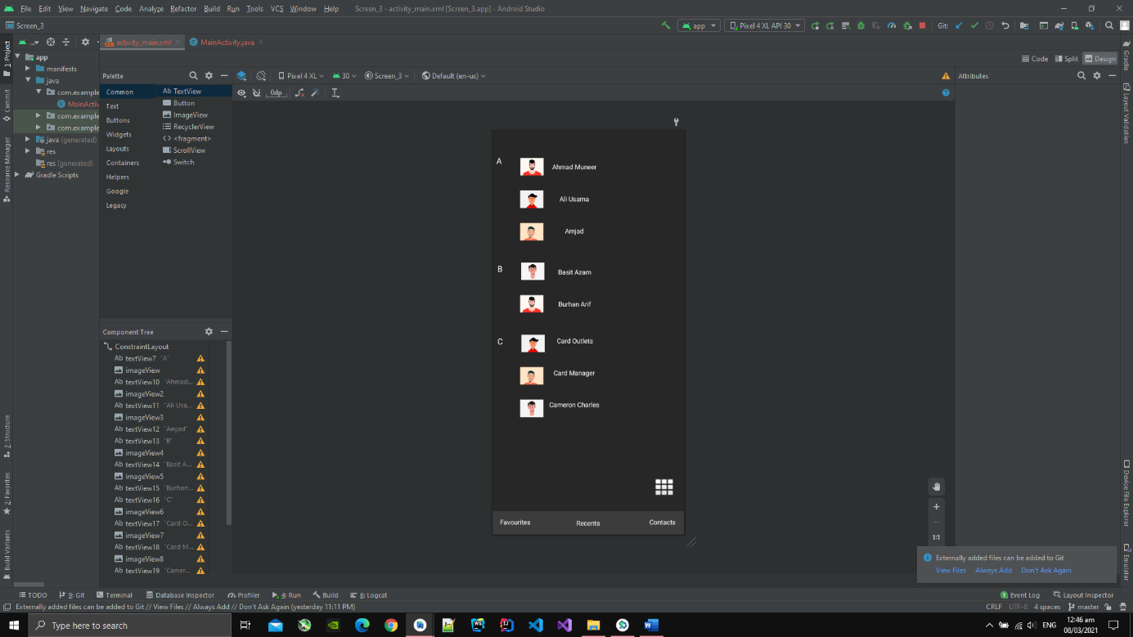

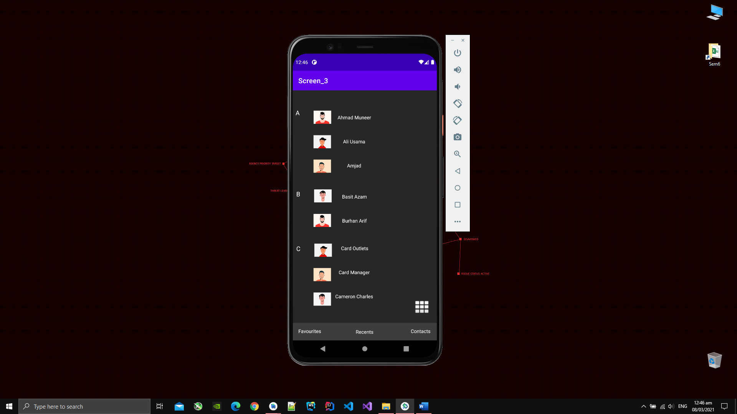

**Activity and Intent**

1. I have created two activites named MainActivity.java and MainActivity2.java.
2. I also have created the layout file for both named activity_main.xml and activity_main2.xml.

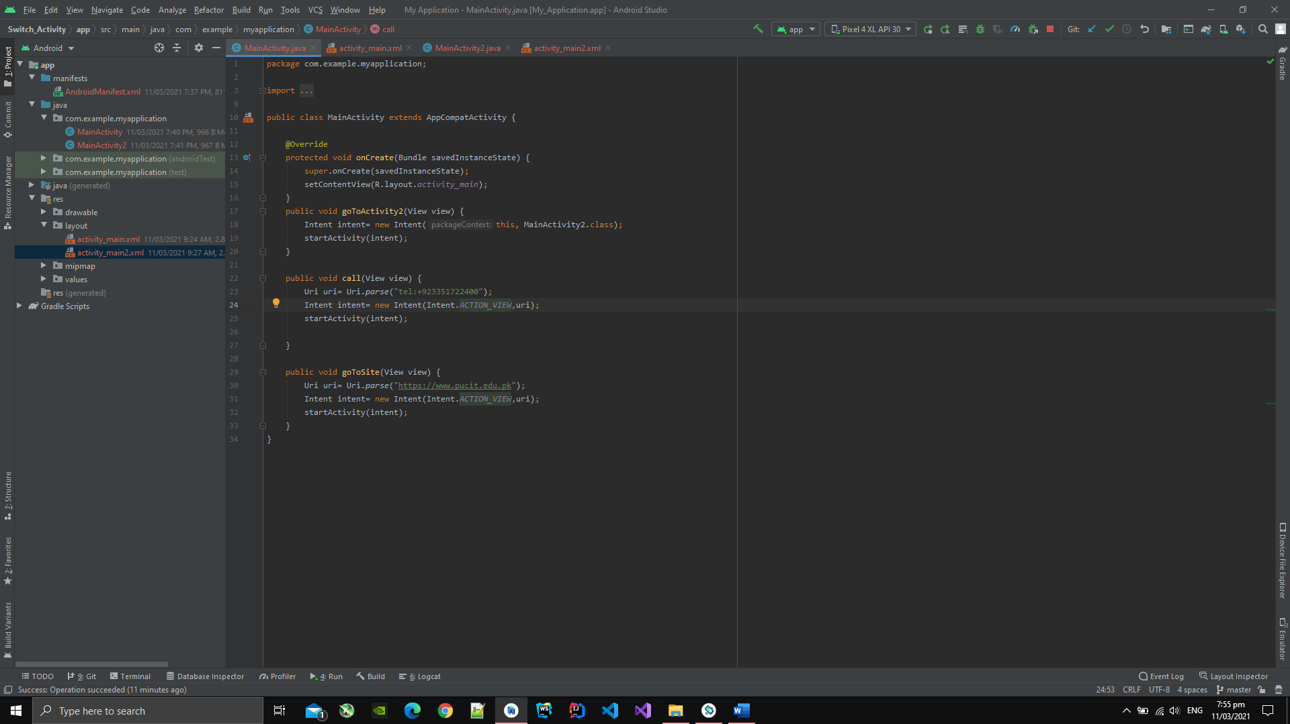

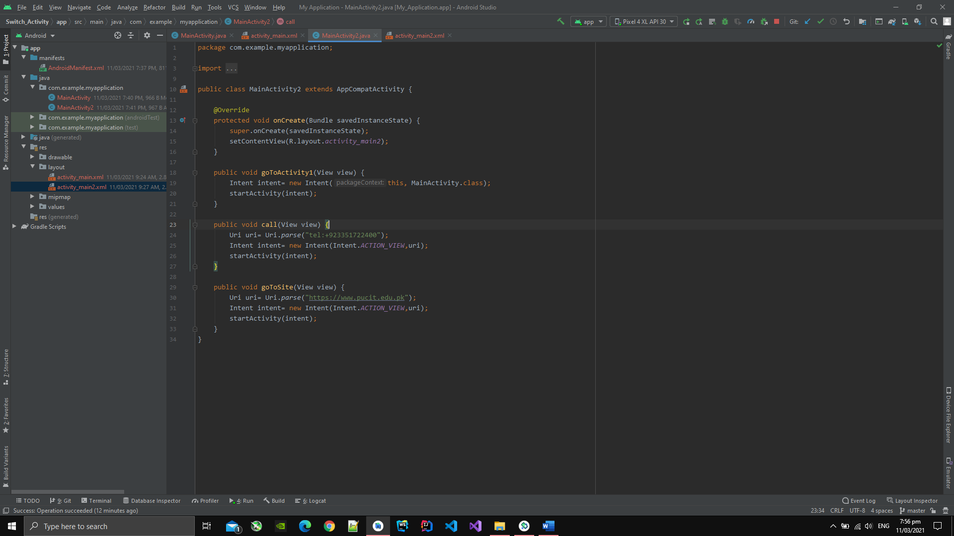

1. The layout activty_main.xml has three button and one textview.

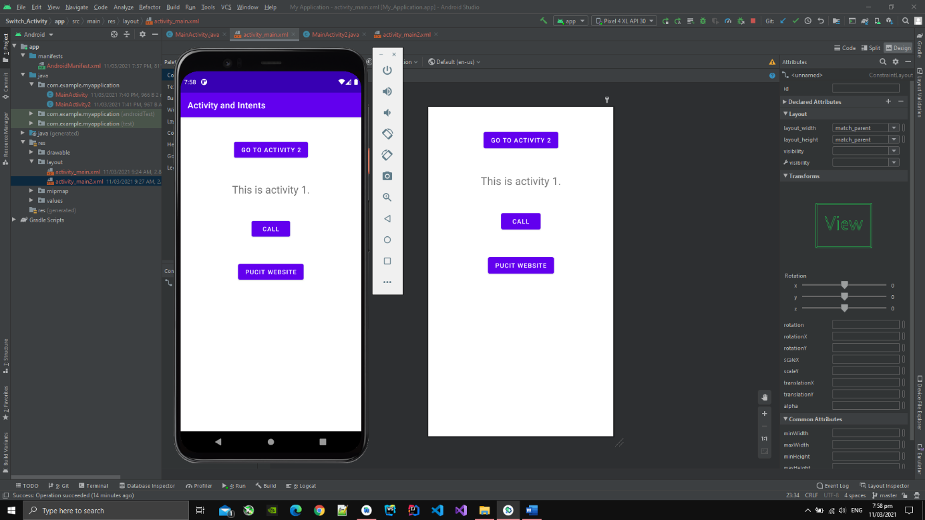

1. After pressing the CALL button on first layout the dialer will open with a number already in it to call.

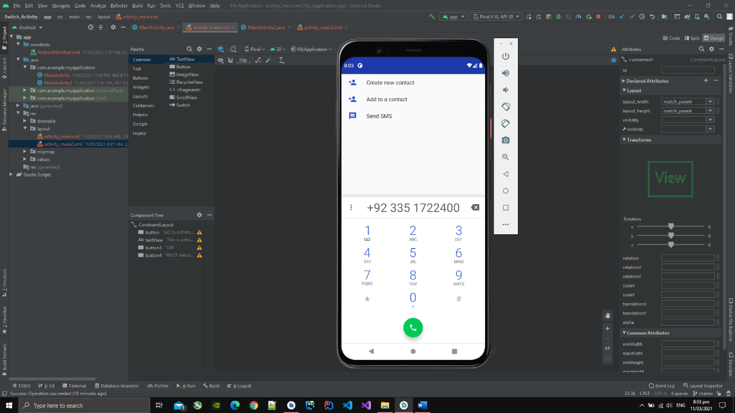

1. After pressing the button PUCIT WEBSITE button it will move to the pucit site on the browser.

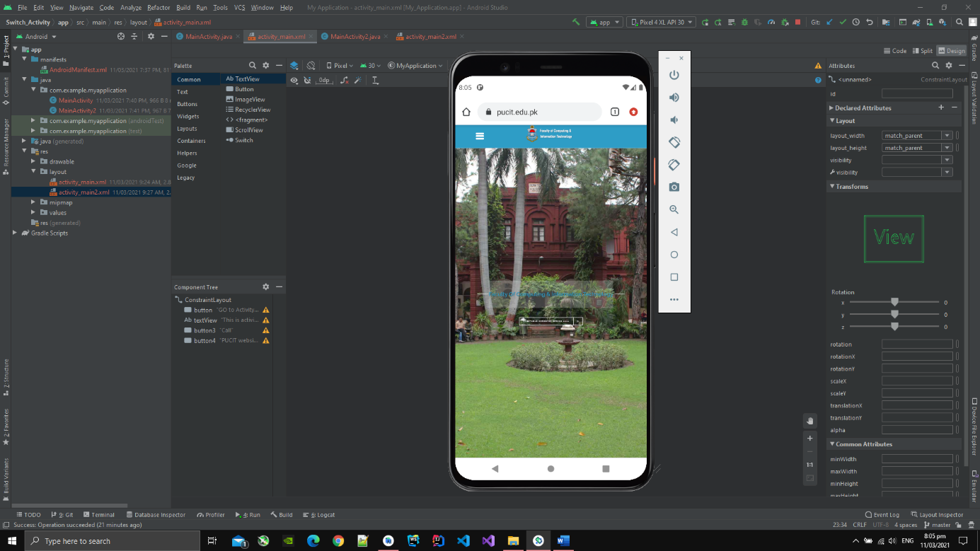

1. After pressing the button GO TO ACTIVITY 2 the activity will switch to the MainActivity2.java.

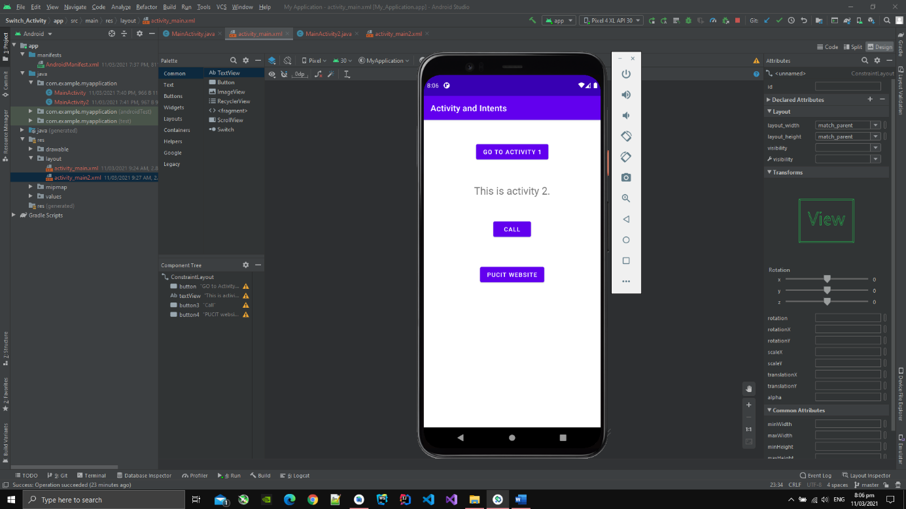

1. The layout activty_main2.xml has three button and one textview.

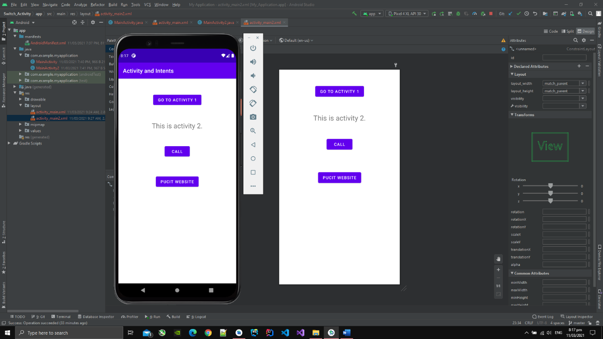

1. CALL and PUCIT WEBSITE serve the same purpose as in the first view.
2. GO TO ACTIVITY 1 button the activity will switch to the MainActivity.java.

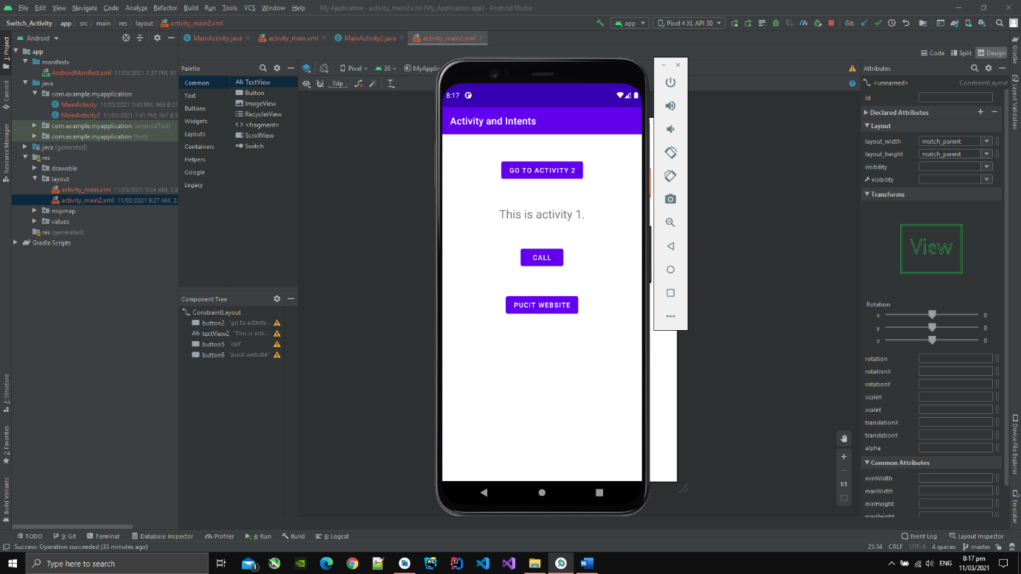

**Counter and Activity Lifecycle**

1. I have created 3 java files and 3 xml files.
2. One java file and xml file has counter implementation. After clicking CLICK button the counter is incremented.
3. After creen rotation, the coutner value is preserved.

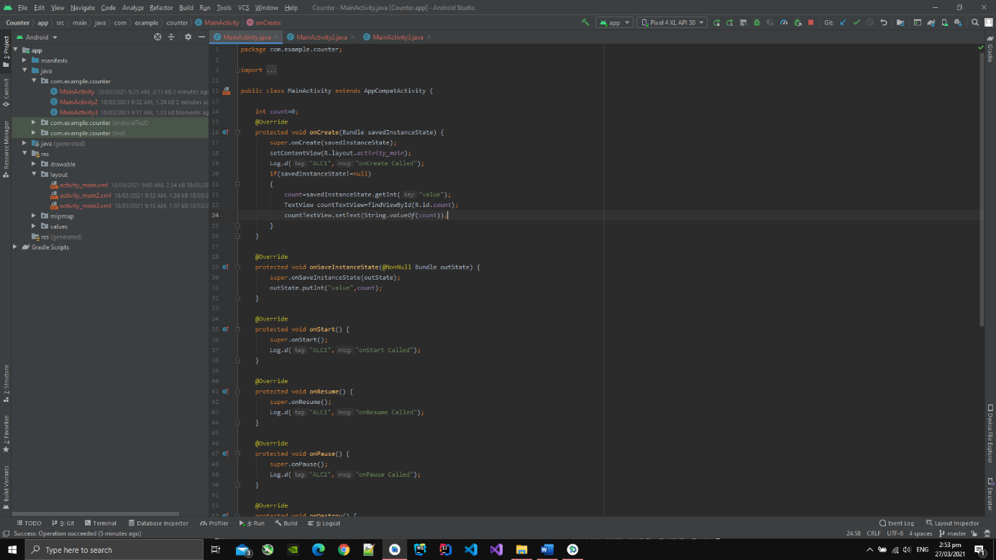

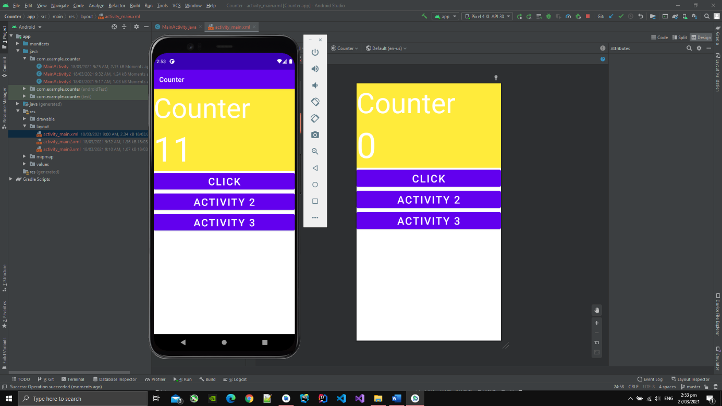

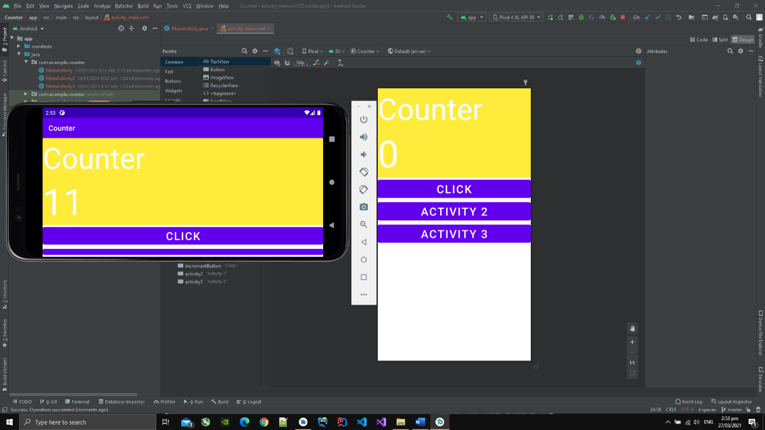

1. After clicking the button ACTIVITY 3, the screen is changed to activity 3 screen.

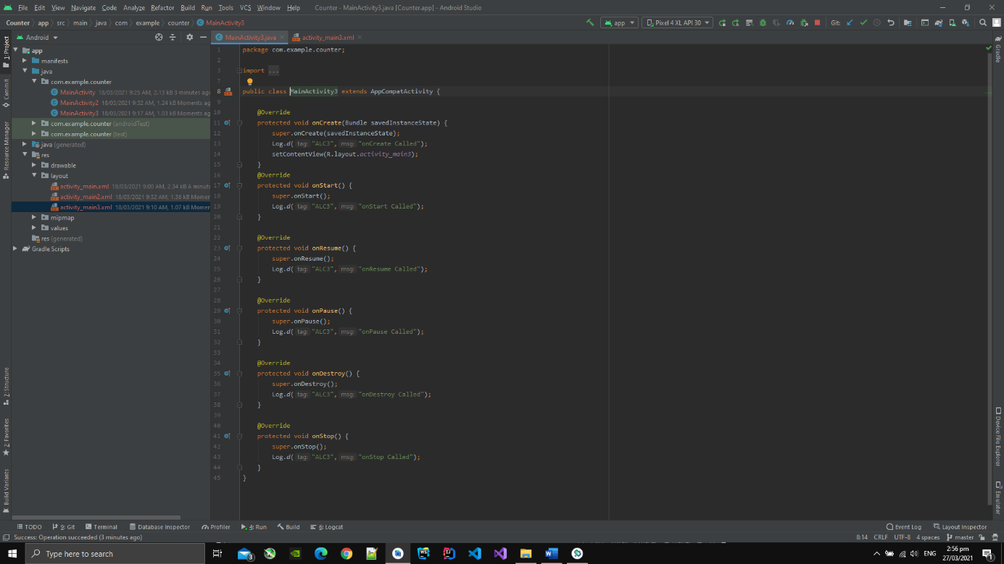

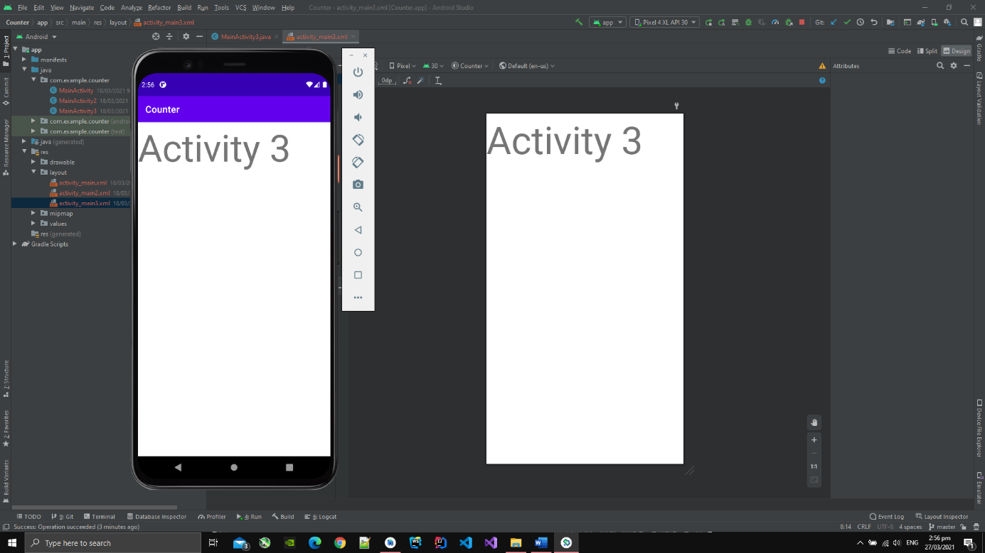

1. After clicking the button ACTIVITY 2, the screen is changed to to activity 2.
2. Then activity 2 also has a button which on pressing, the screen is changed to activity 3.

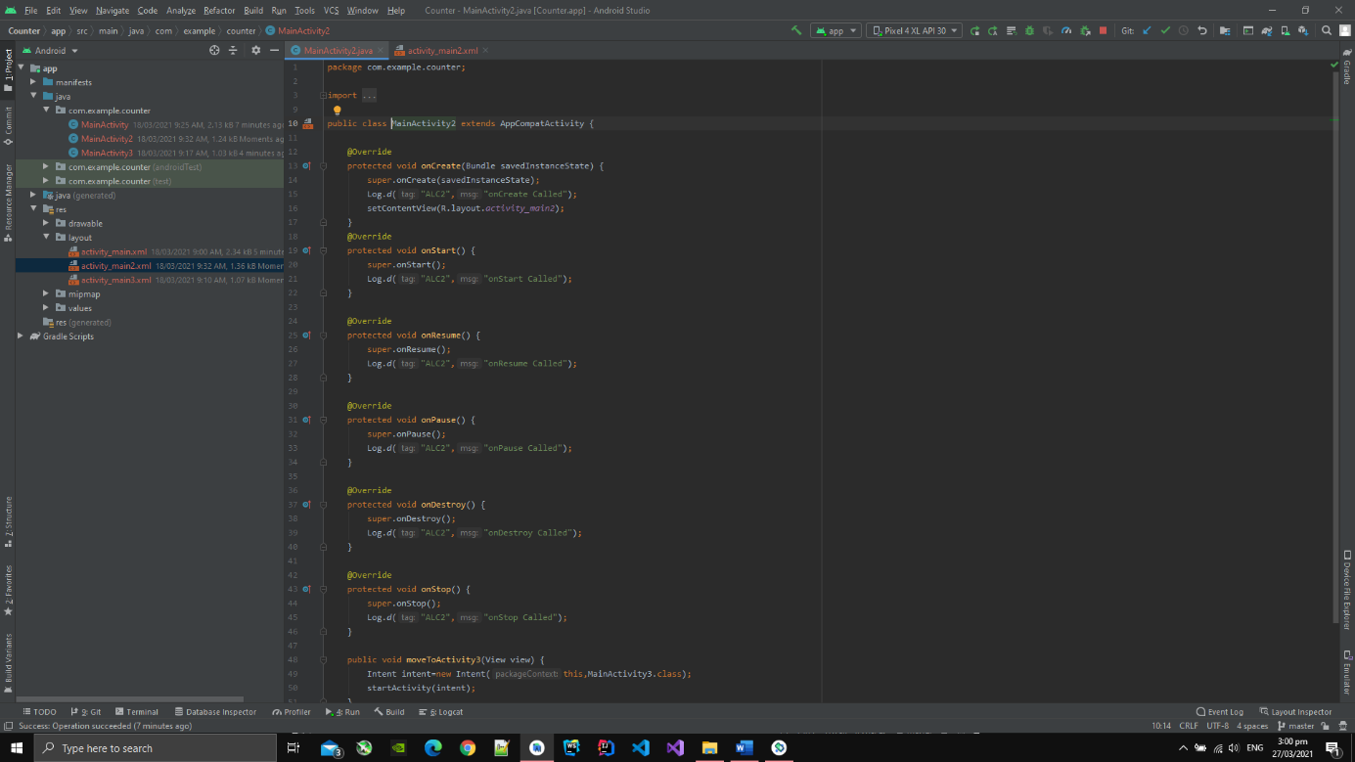

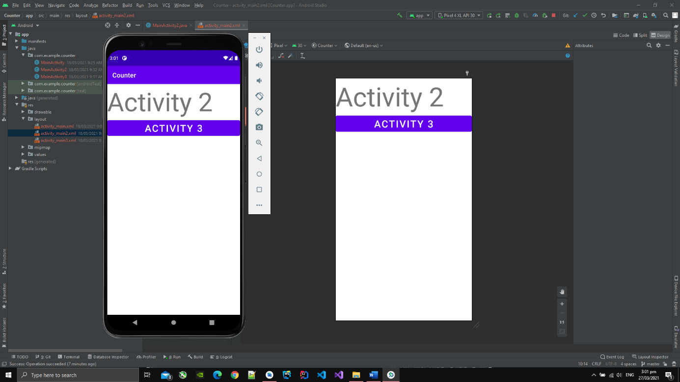

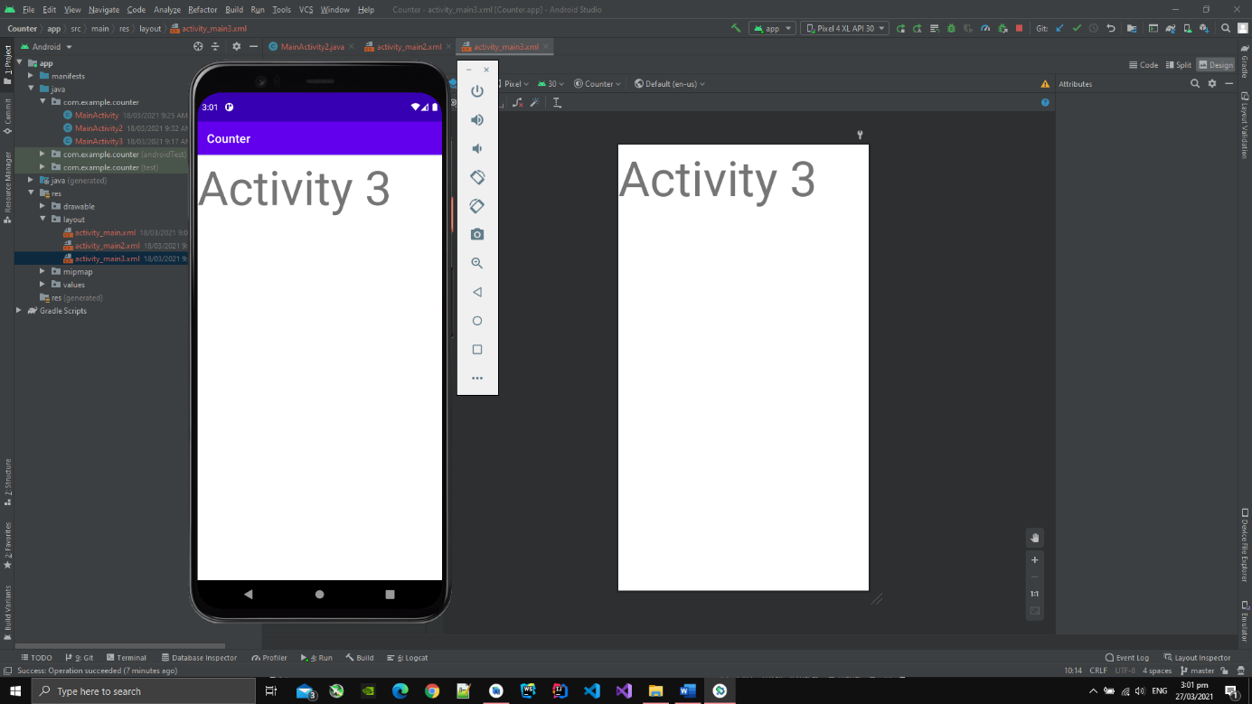

**ListViews**

1. I have implemented ListView which takes input from user.
2. After writing name and then pressing ADD button, the name is inserted in the ListView.

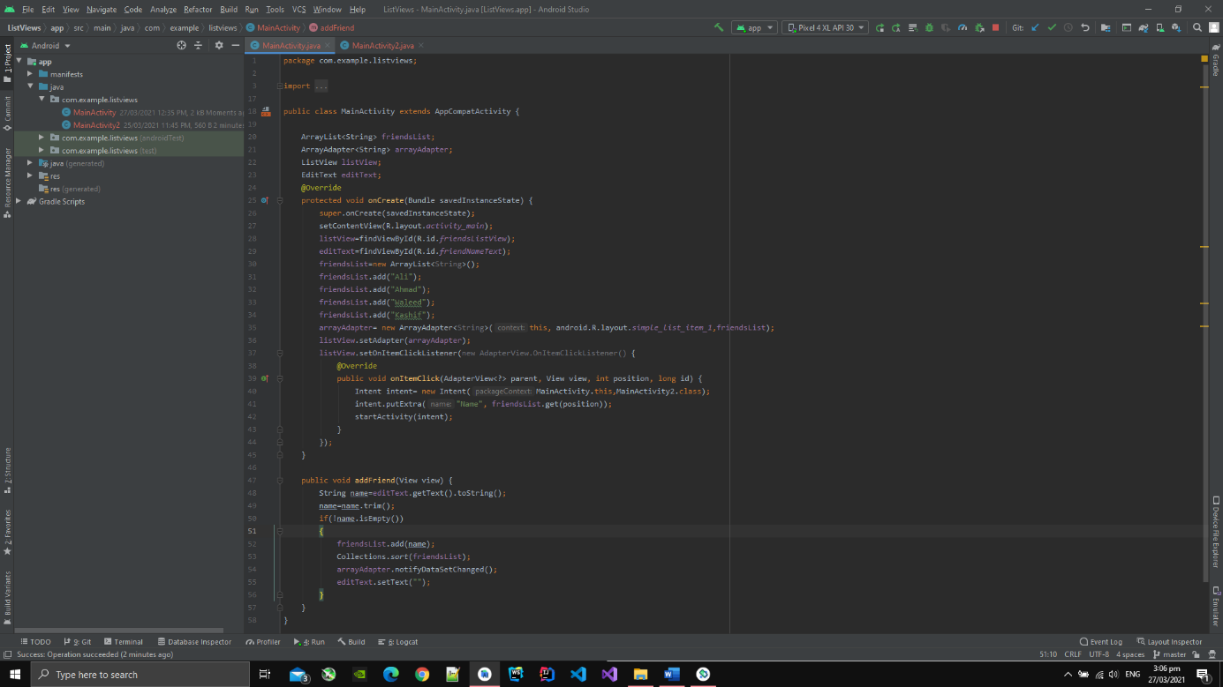

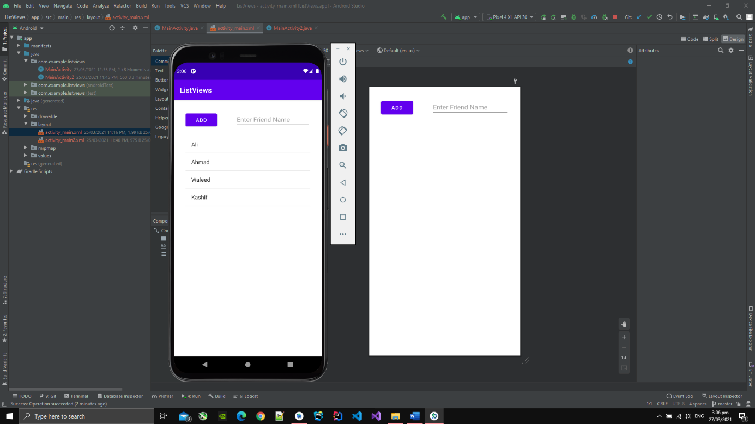

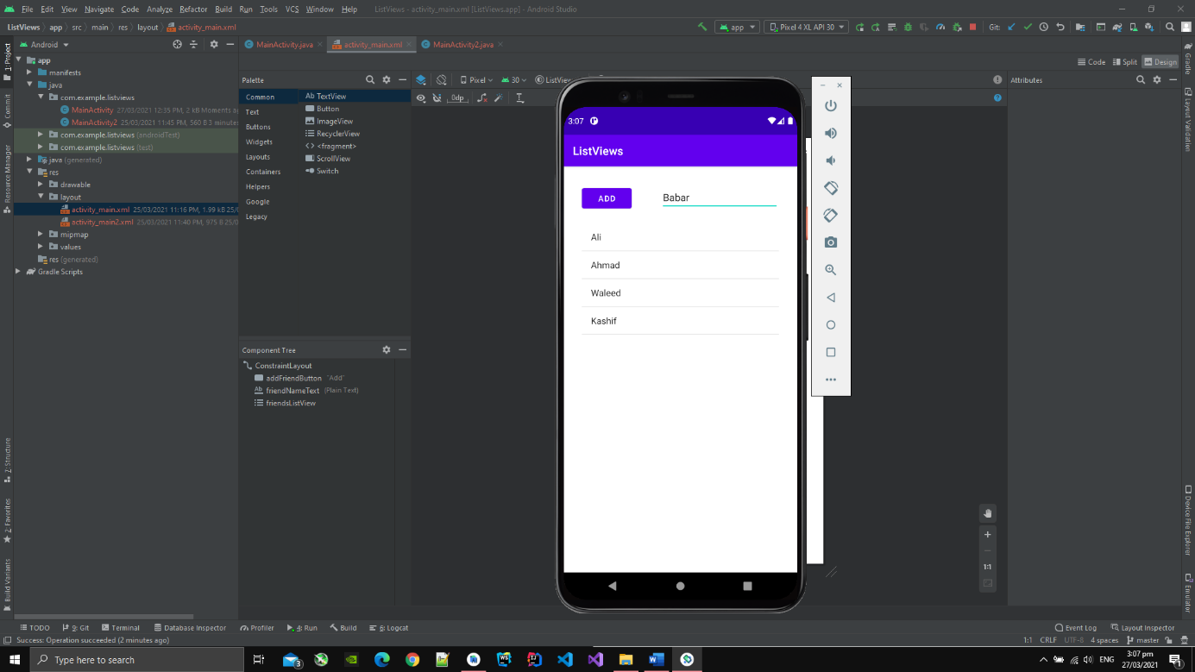

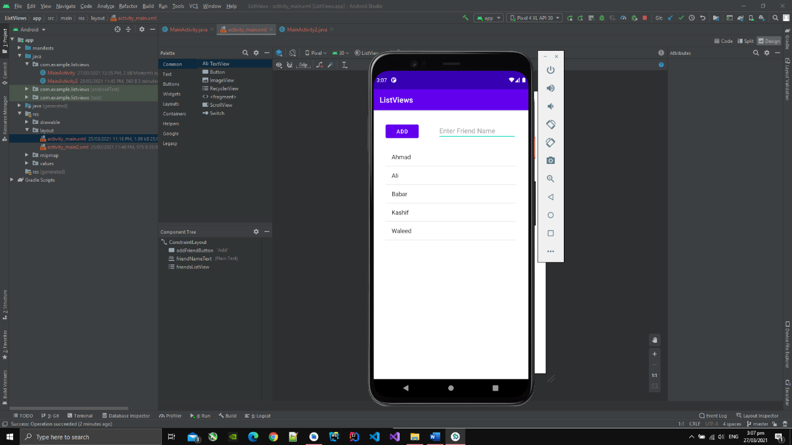

1. If I click on any name in the ListView ,then name screen is changed and the name that was pressed appears on the screen.
2. I pressed Babar and then Babar appeared in screen.

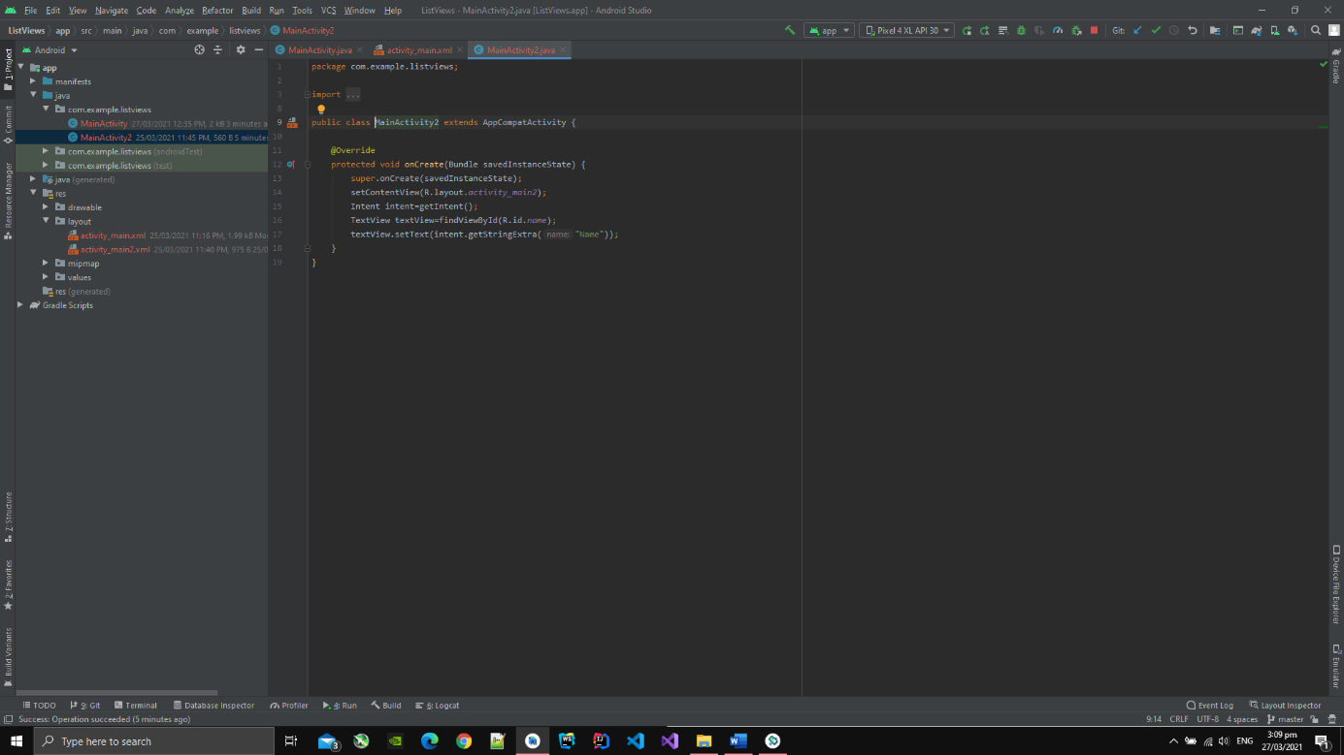

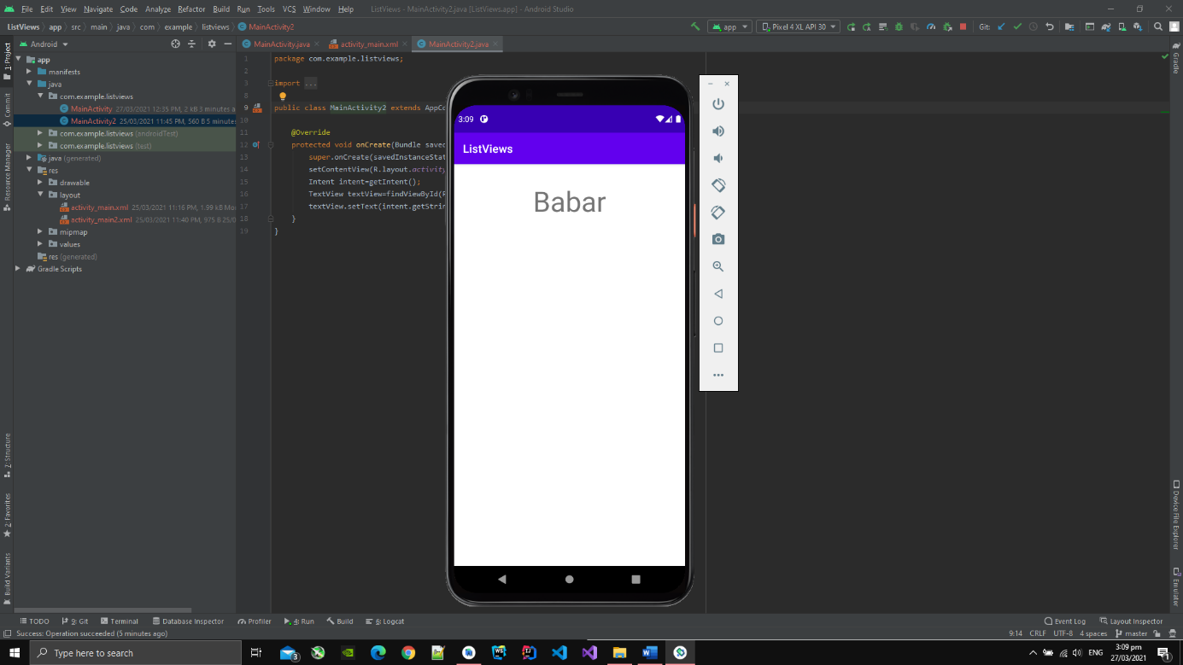

**Seekbar**

1. I have created a Seekbar and a ListView.
2. On moving the Seekbar, the table of number is added in the ListView to which the Seekbar is currently pointing.

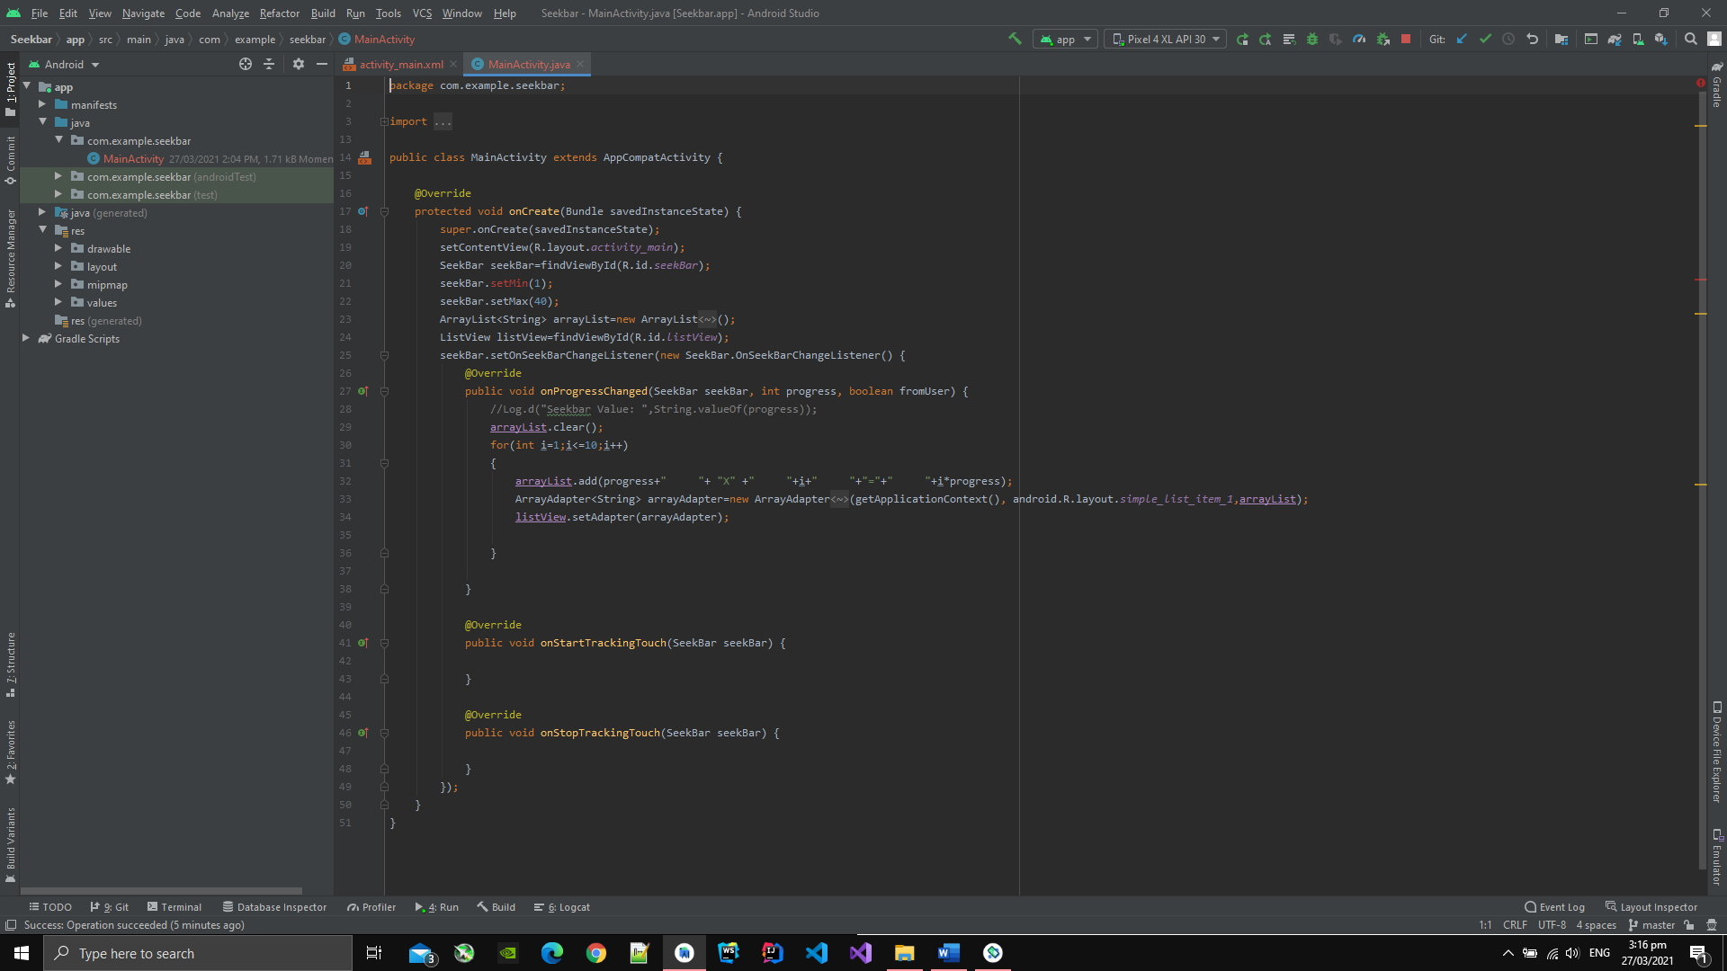

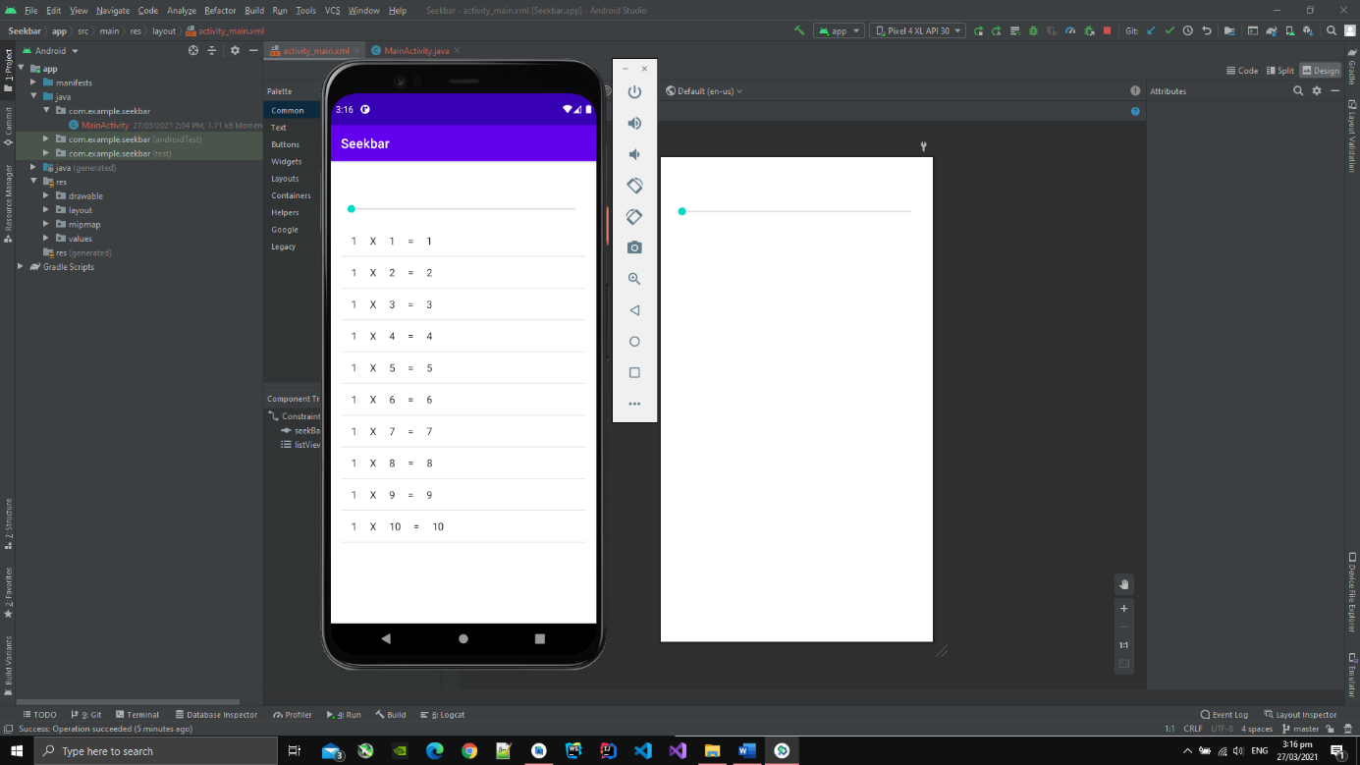

1. After moving the Seekbar, the ListView is updated as shown below,

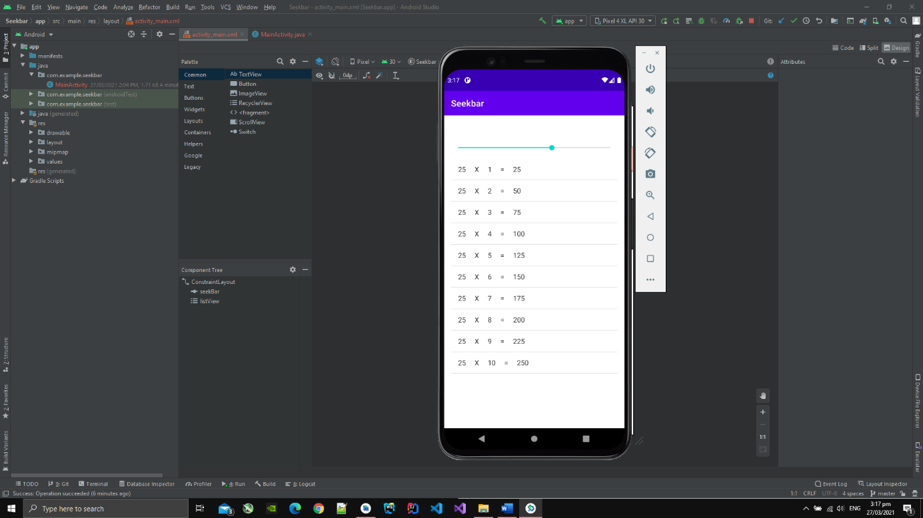

**Image and Animations**

1. I have created an ImageView and added an image of batarang in it.
2. After tapping the image, the image is animated by rotating and the image is interpolated across X and Y axis by as show in image below.

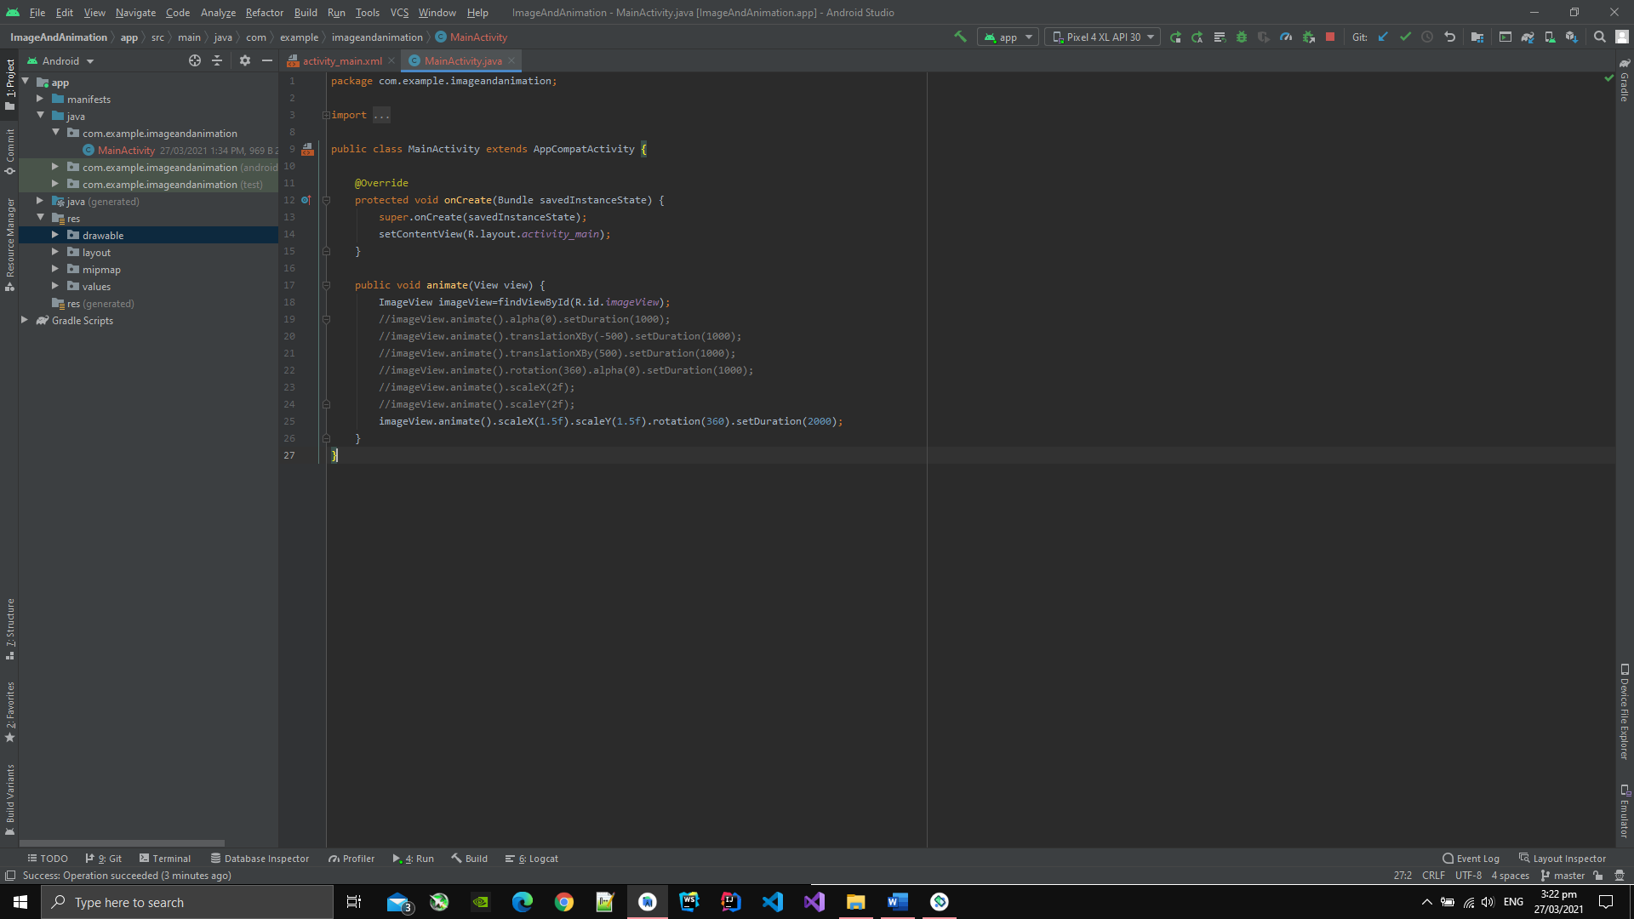

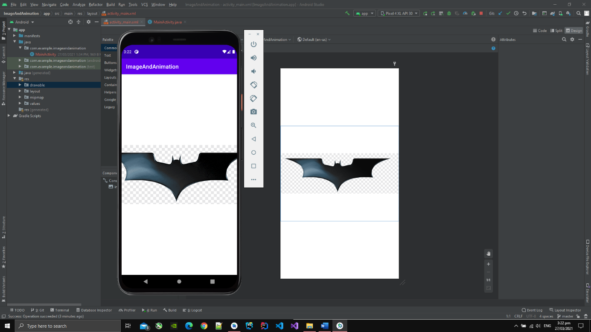

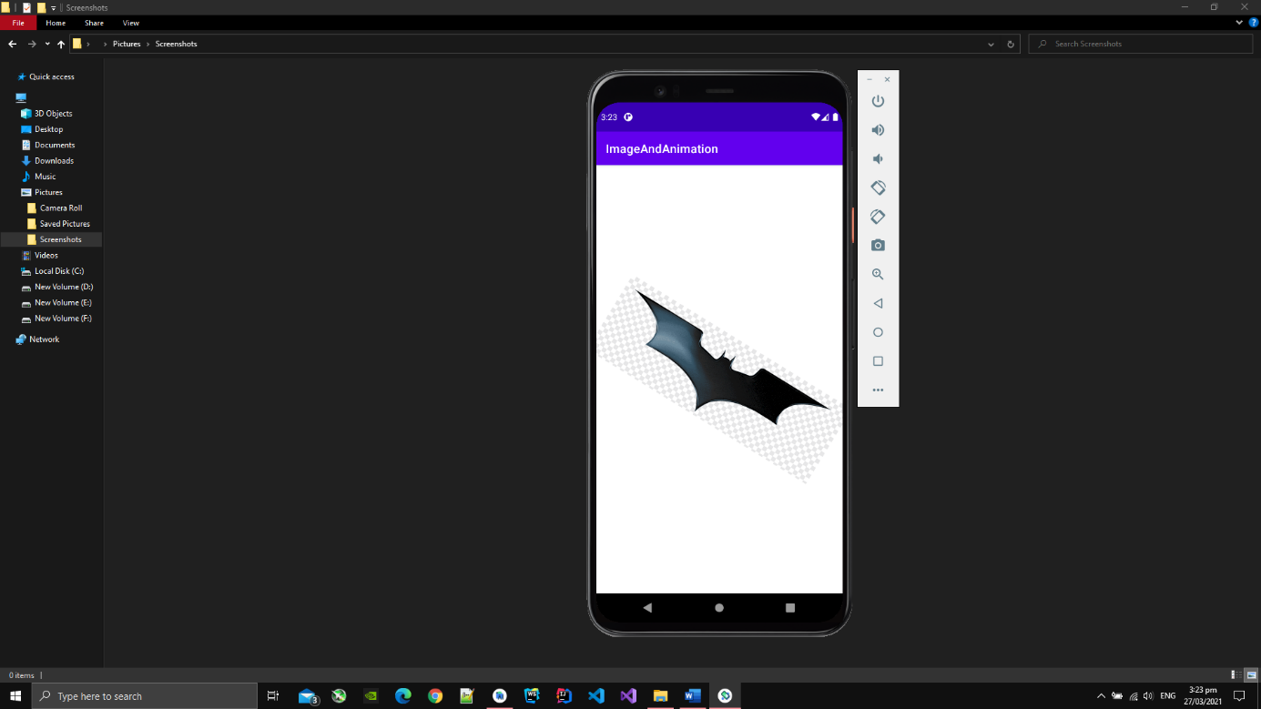

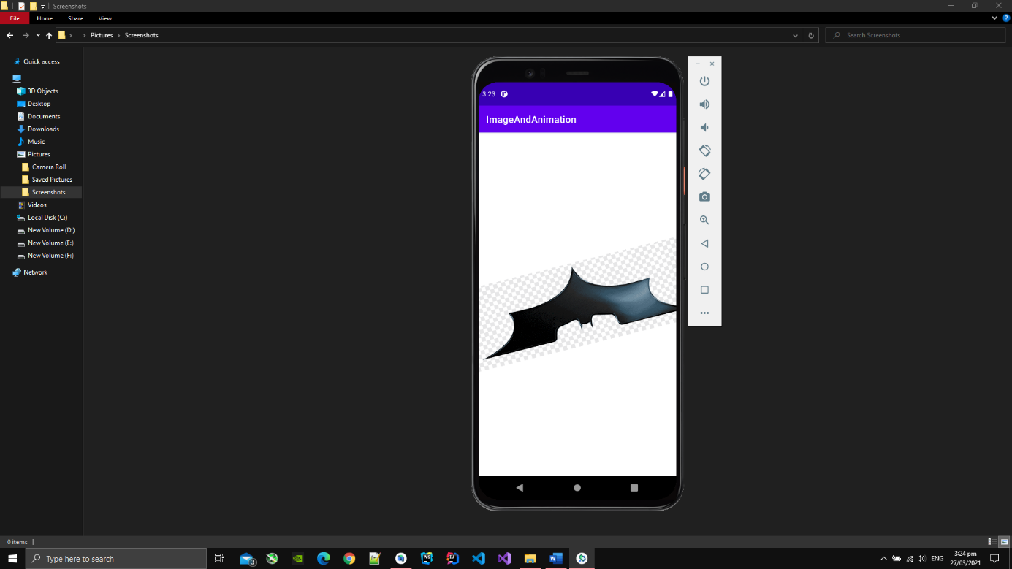

**Videos**

1. I have created VideoView and MediaController.
2. On application startup, the video is played automaically.
3. MediaController will help to play, pause, forward and reverse the video.

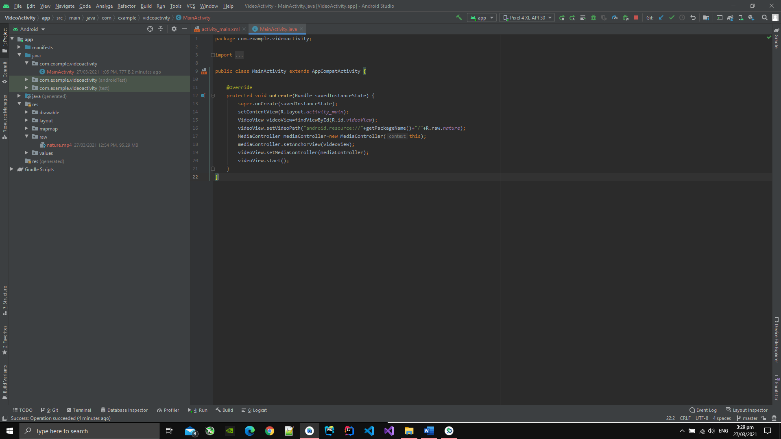

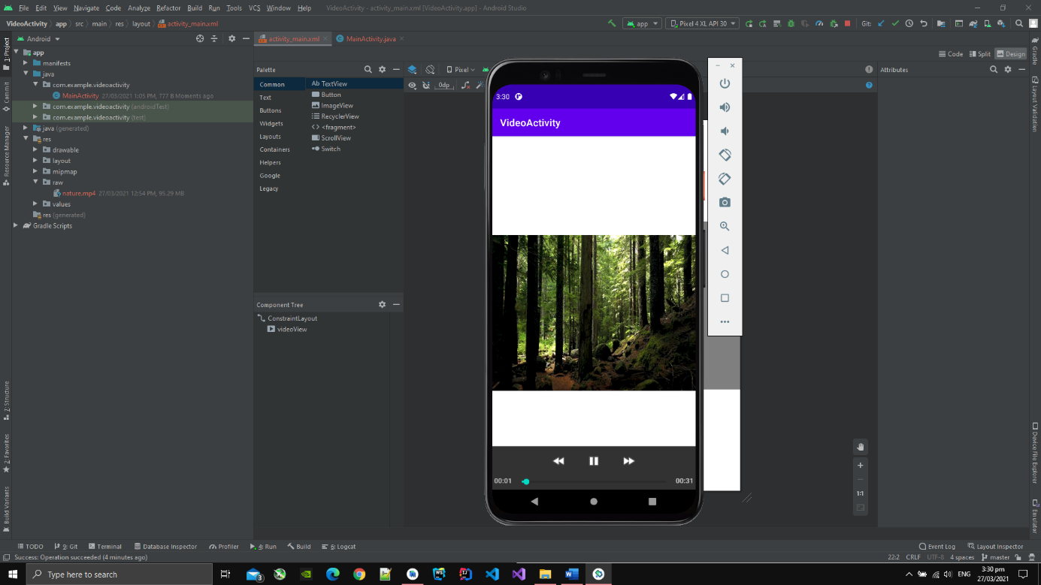

**Audio**

1. I have created a MediaPlayer object and has passed an audio to it.
2. I also have added two buttons to play and pause the audio.

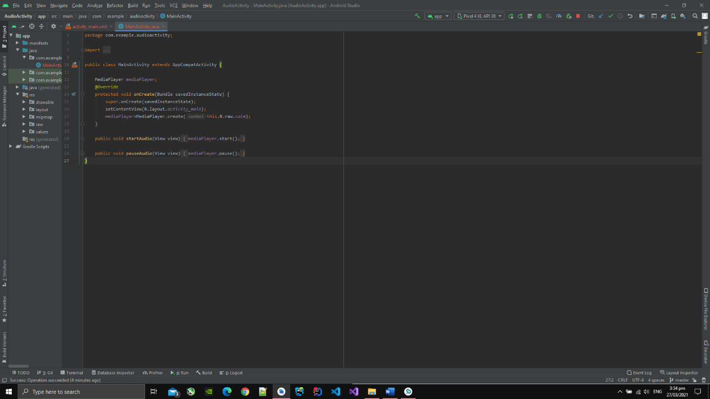

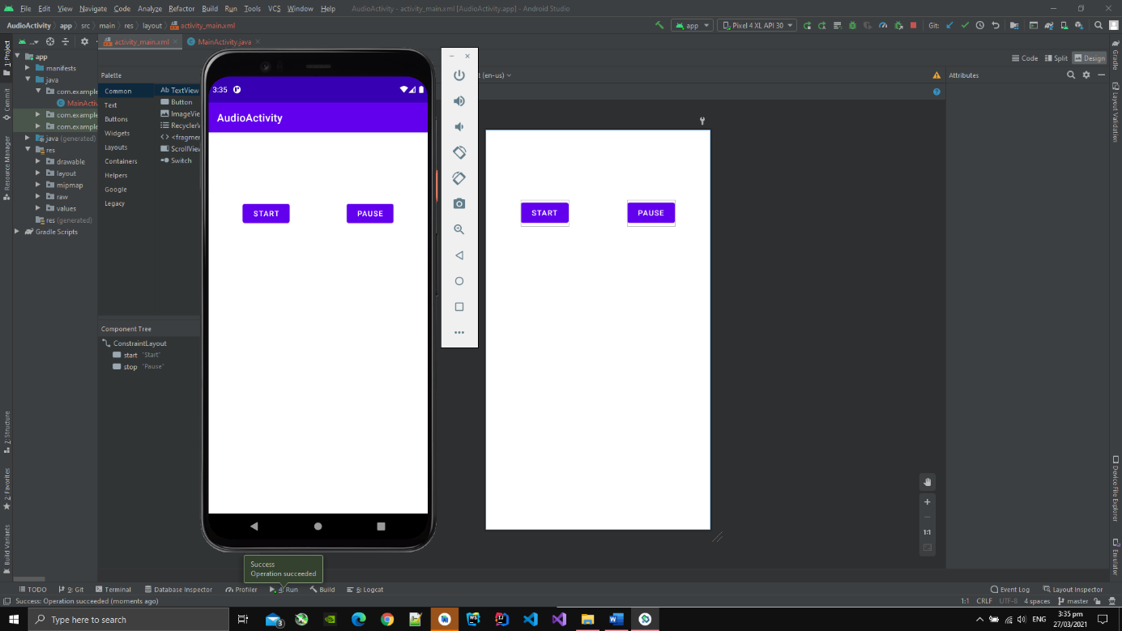

**Database**

1. I have added two text box, two button, 1 switch and a list in this application.
2. I have also used database in this application to store the customer info.
3. Now the list is empty as I have not added any info.

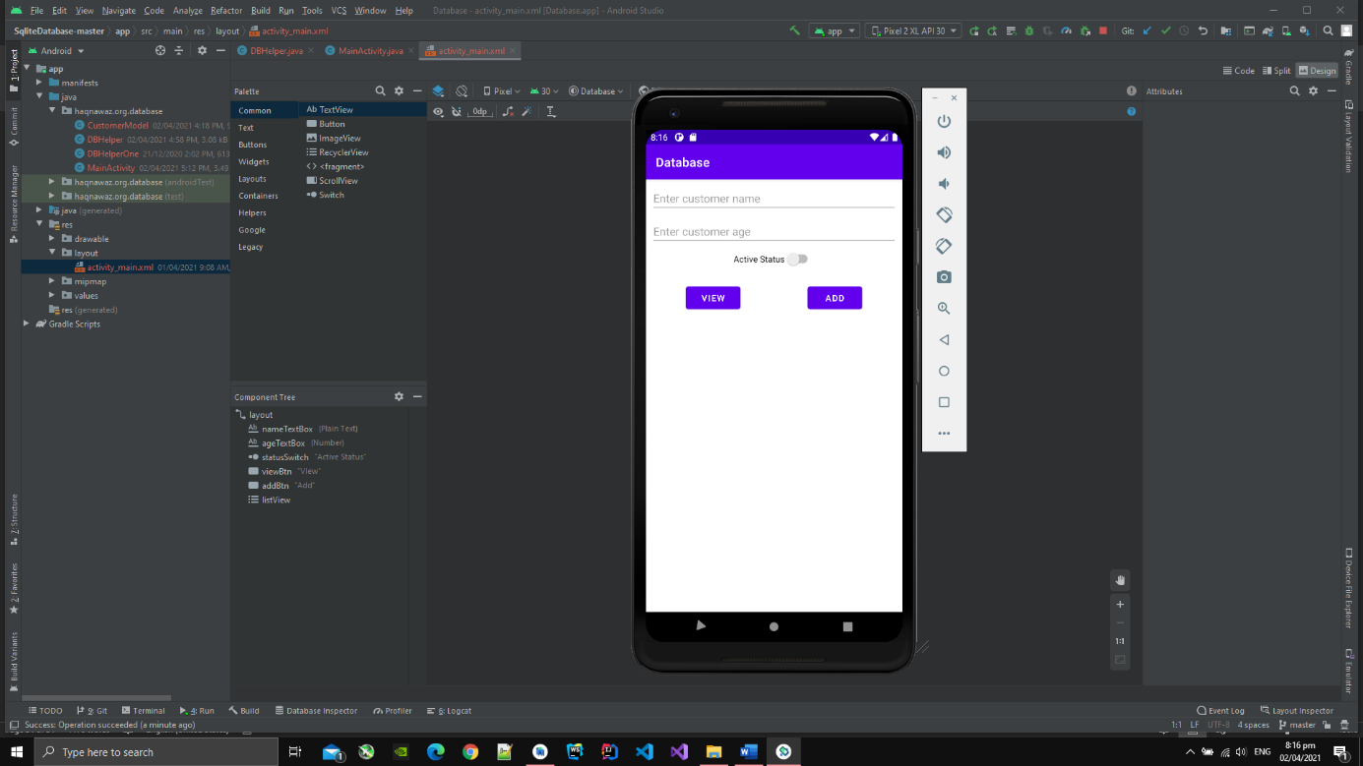

1. Now I have inserted two records in the data base and they are showing below in the list.

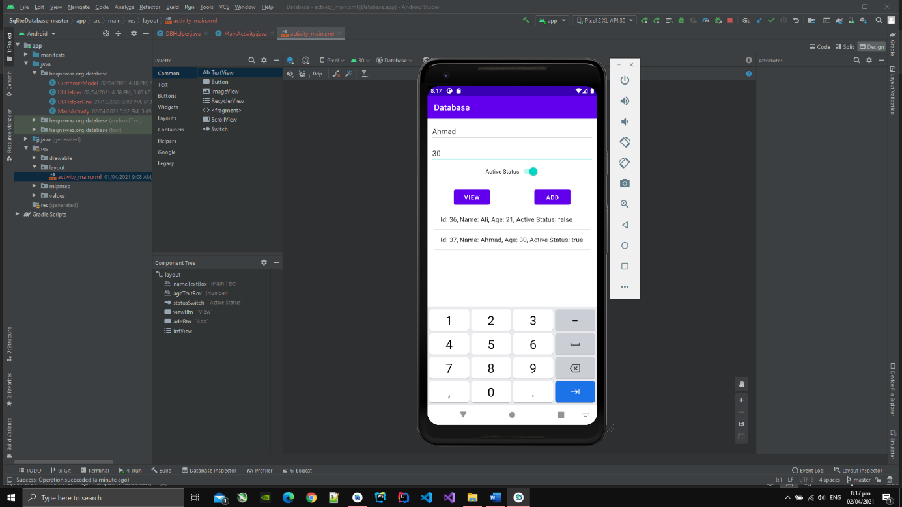

1. I have created a java class named as customer model in which customer object is impletmened.
2. I have also created db helper class in which database related function are written.

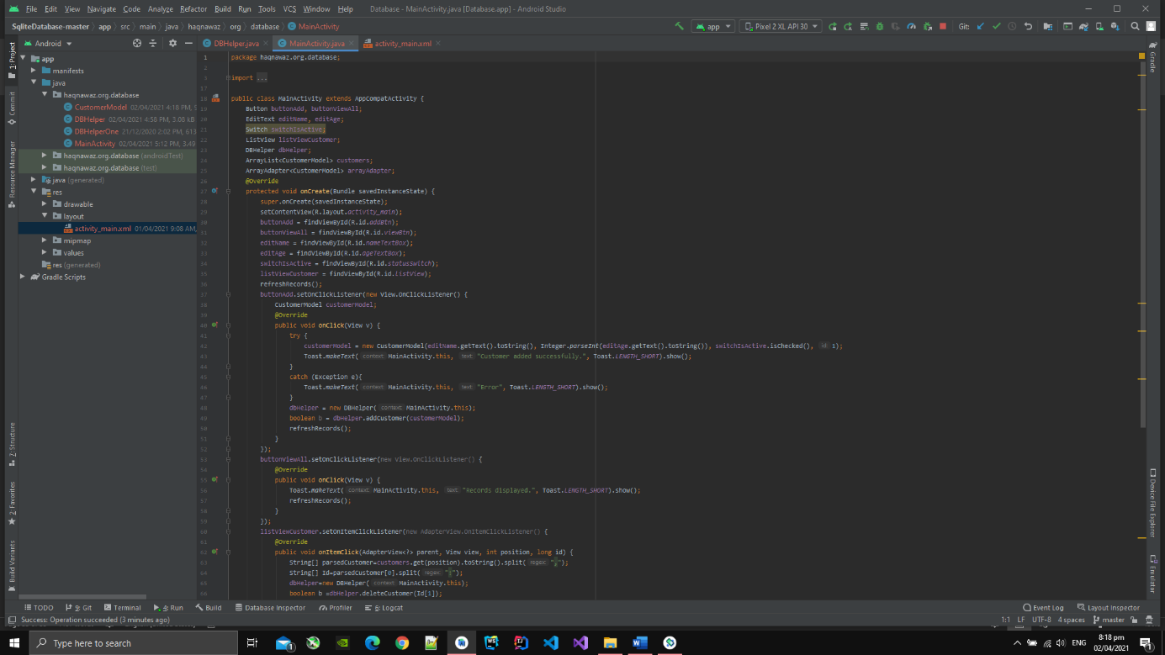

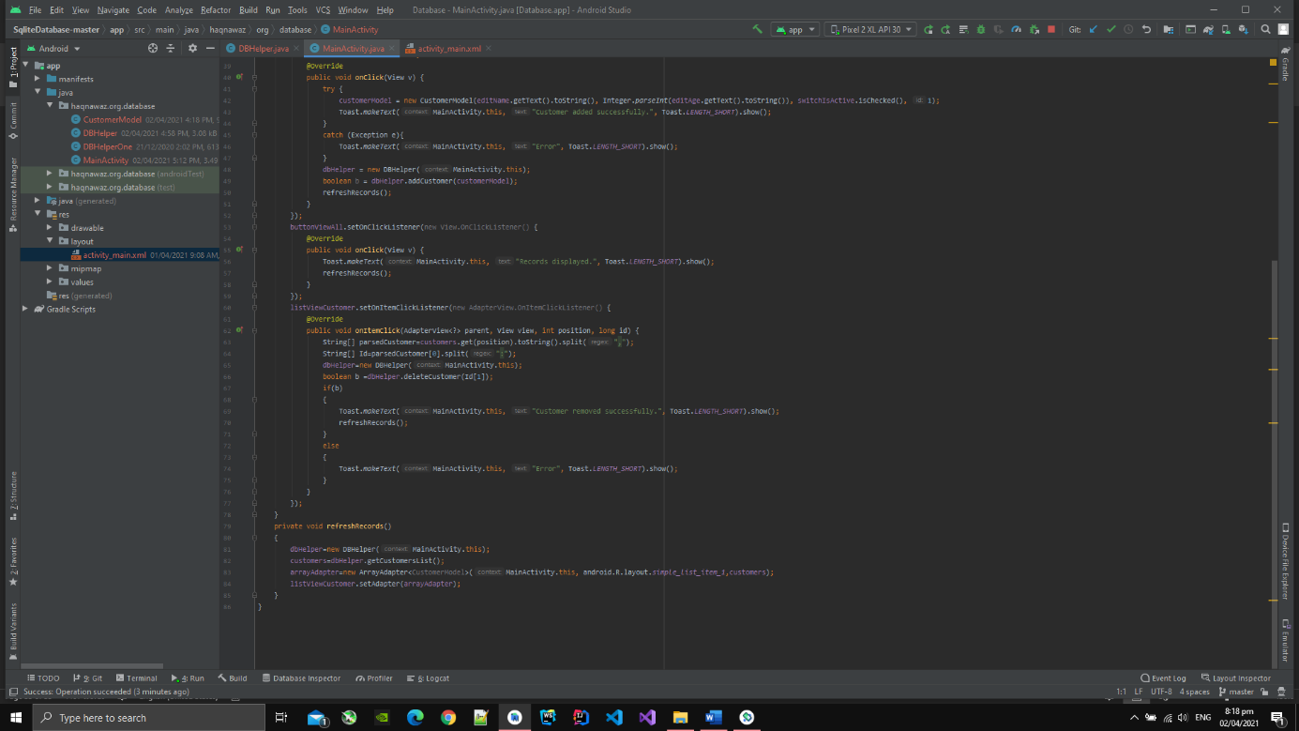

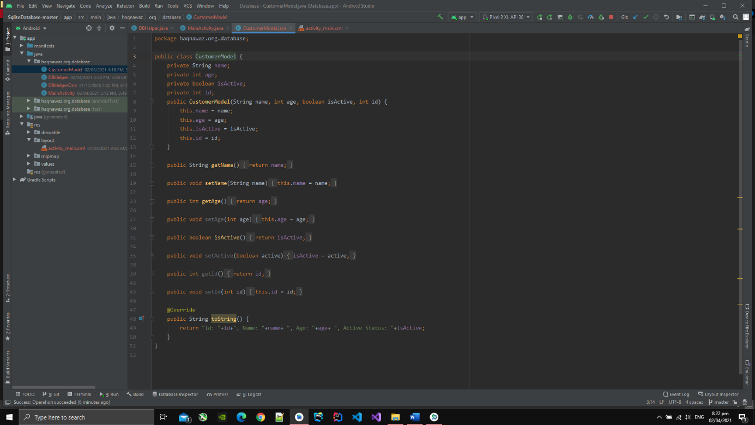

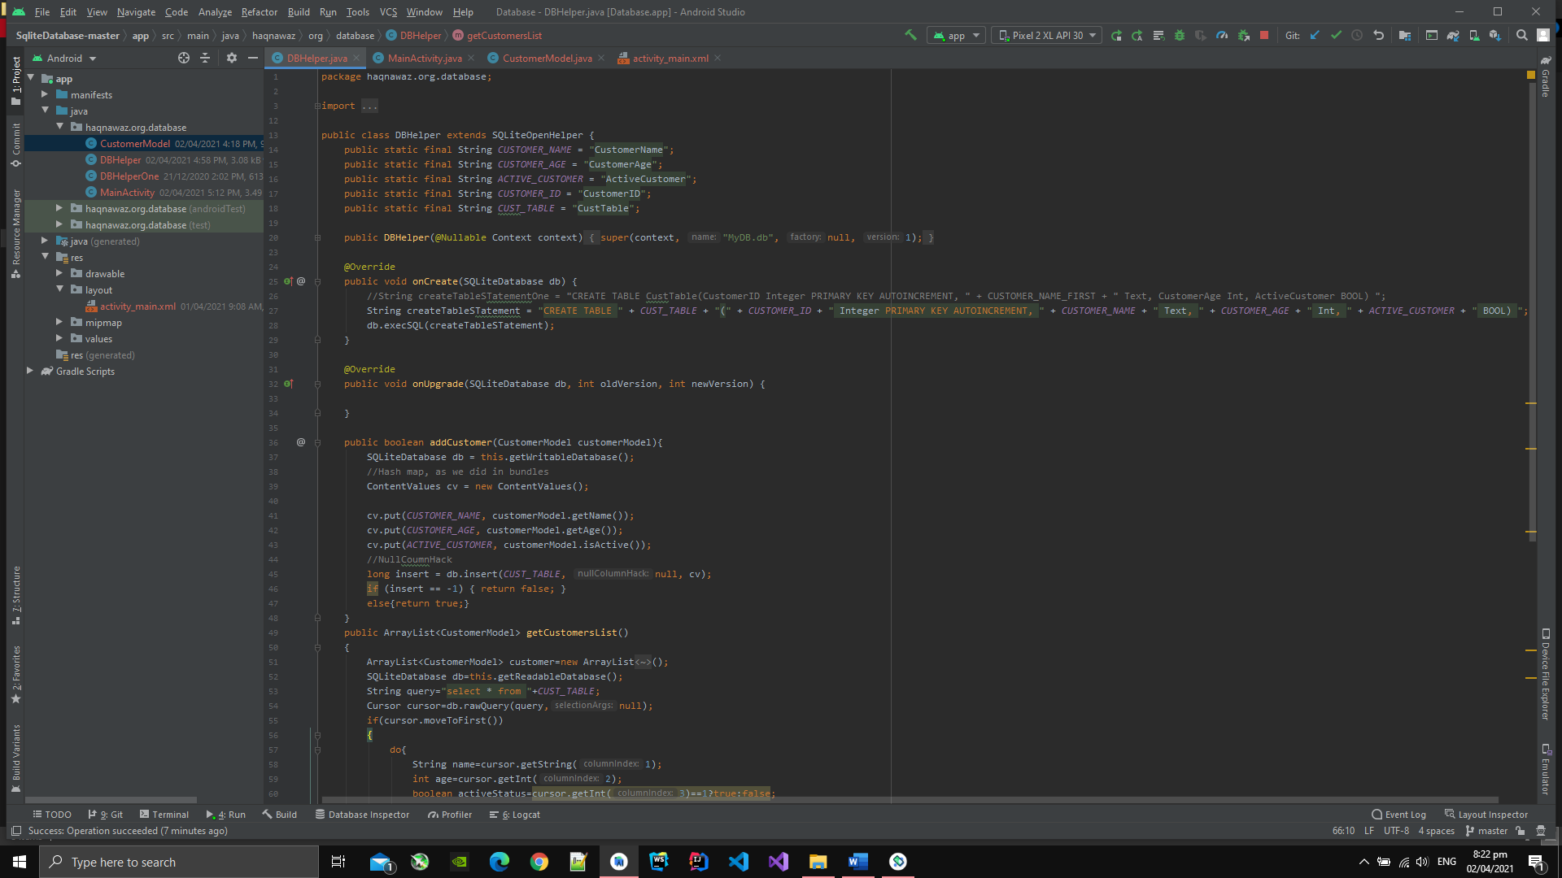

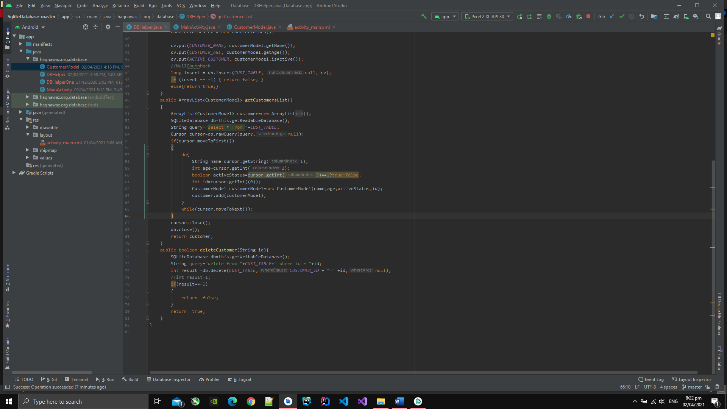

1. After I click on any list item, than that item is deleted from the database and list view is refreshed.
2. In have deleted a record and only 1 record is avaliable now which is shown in pic

below:

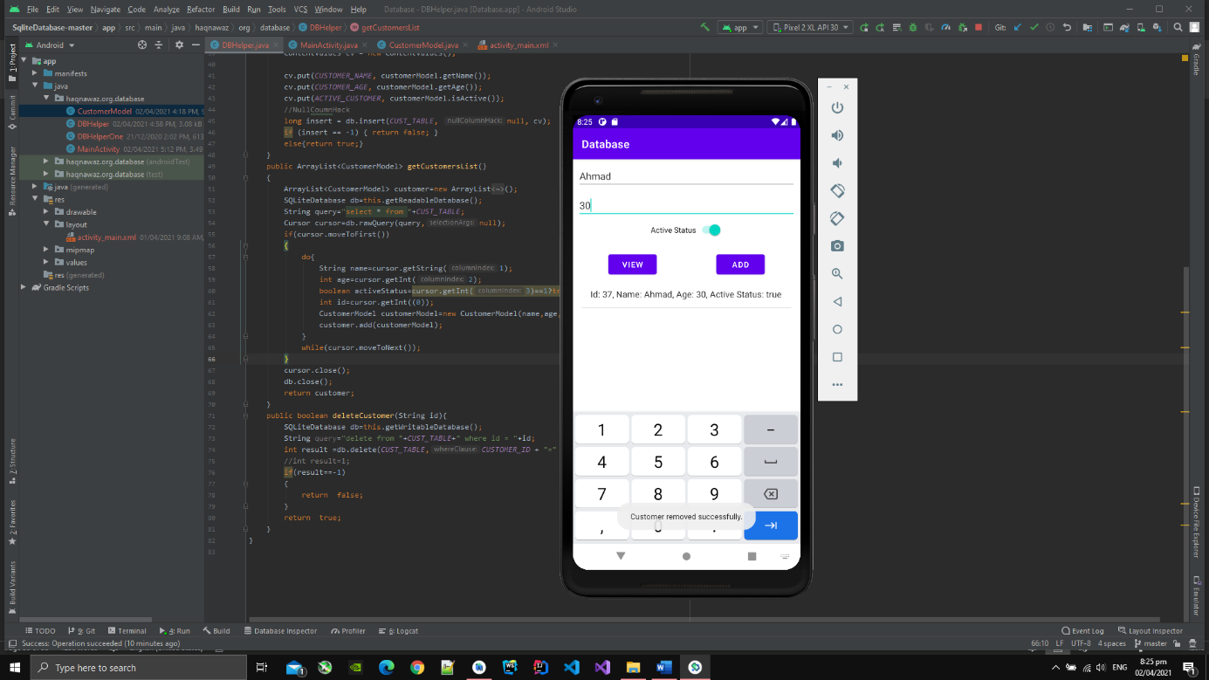

**Drawer Navigation**

1. I have implement navigation drawer.
2. Naviagtion drawer has one header section and one nvigation view which are as given below.
3. Below is shown header section.

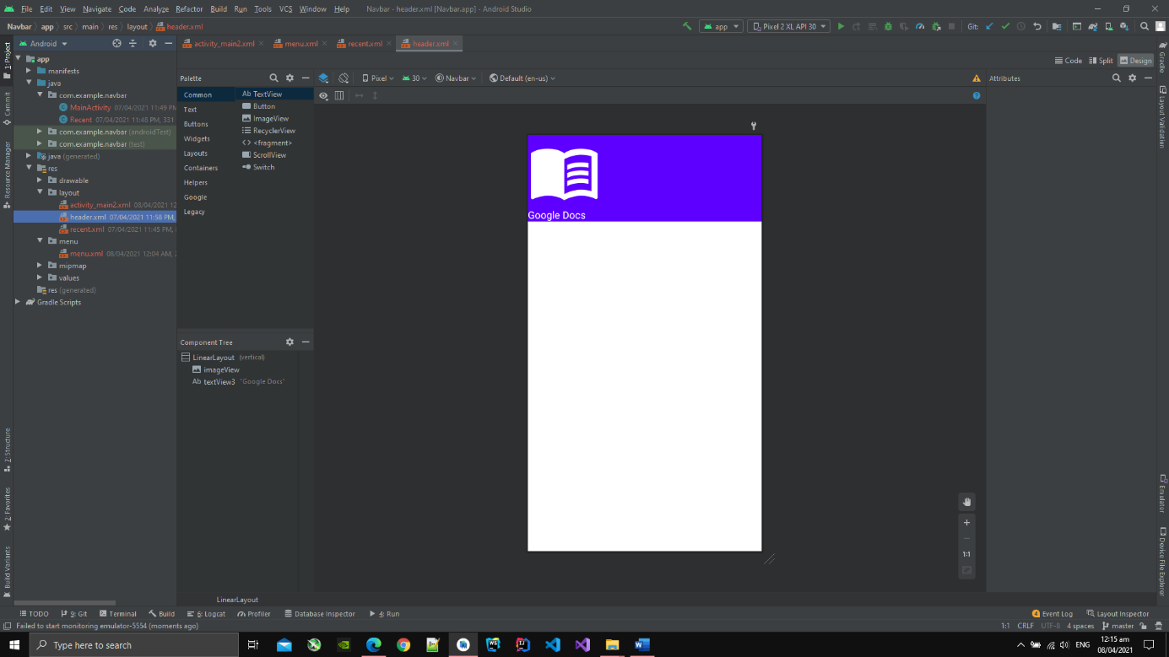

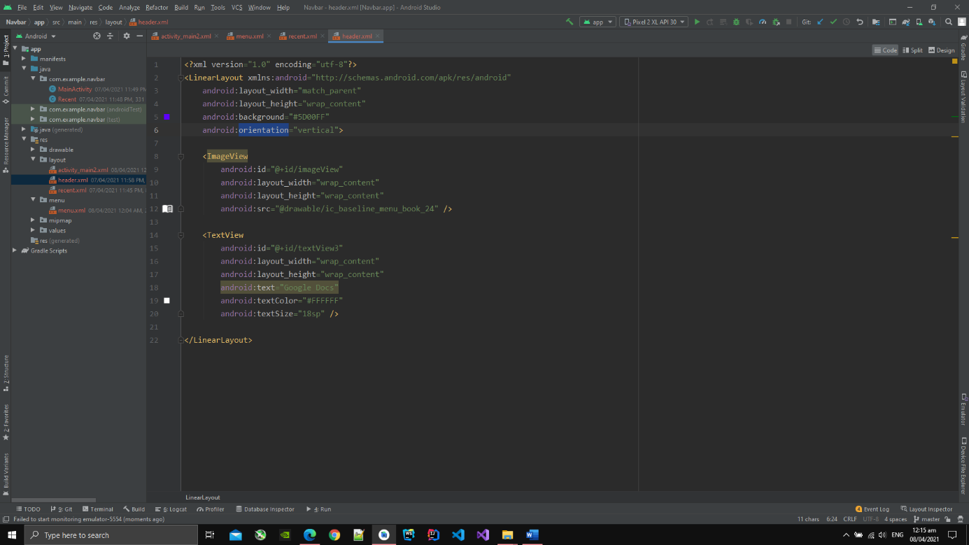

1. Now I have shown navigation view aling with xml code.

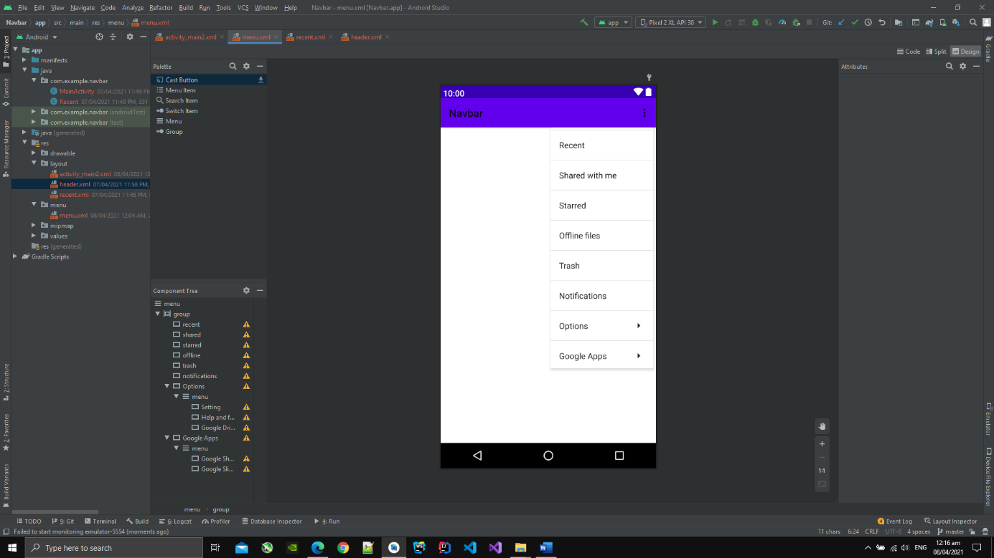

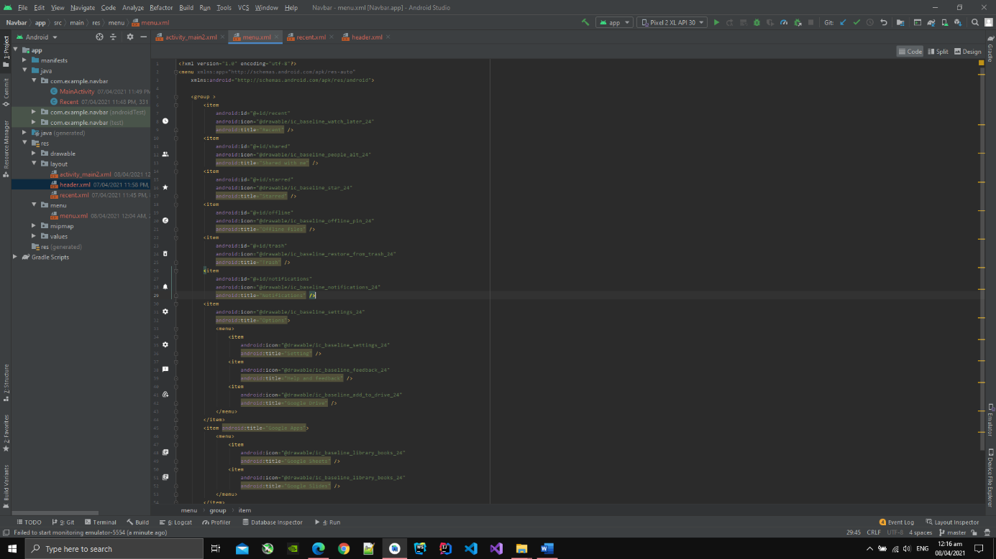

1. As the application starts user is presnented with empty screen having menu button which on clicking display navigation view.

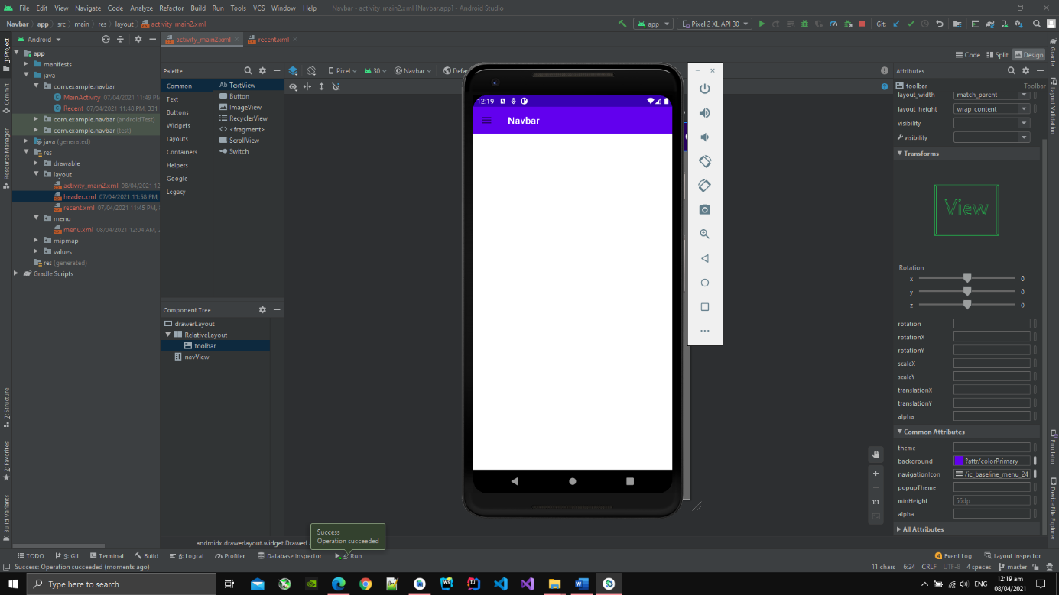

1. After I click the menu icon then the naviagtion menu is displayed which has different options.

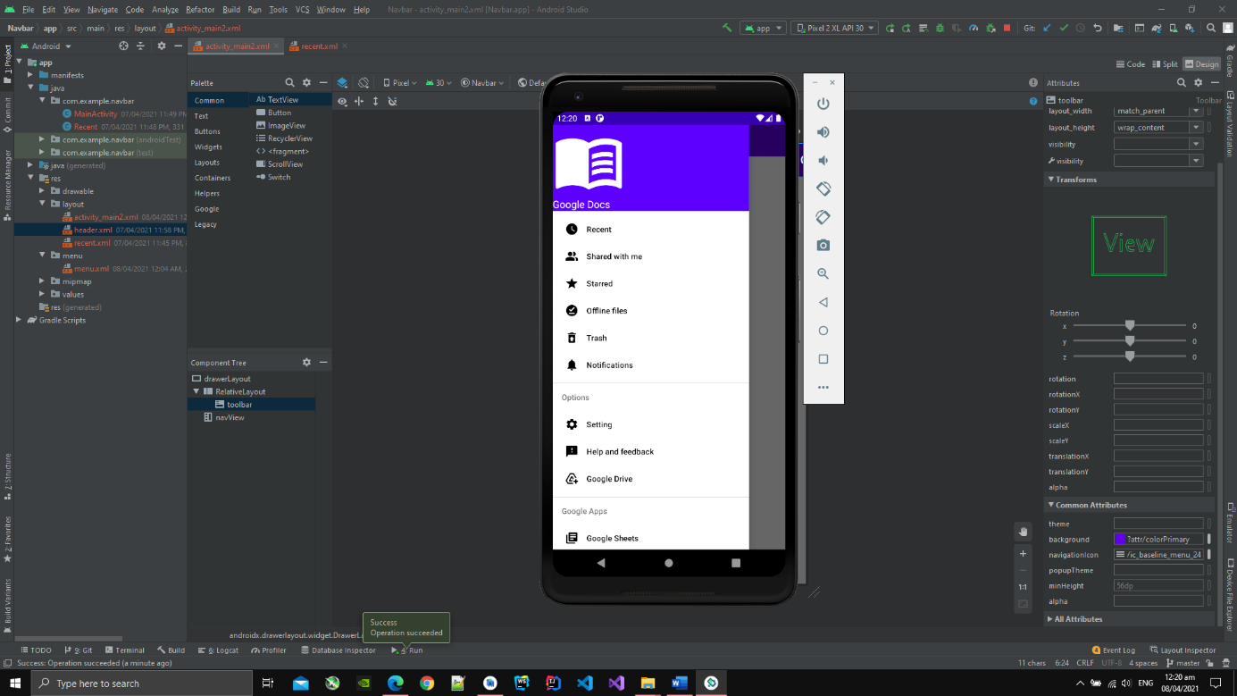

1. Xml code is also given below:

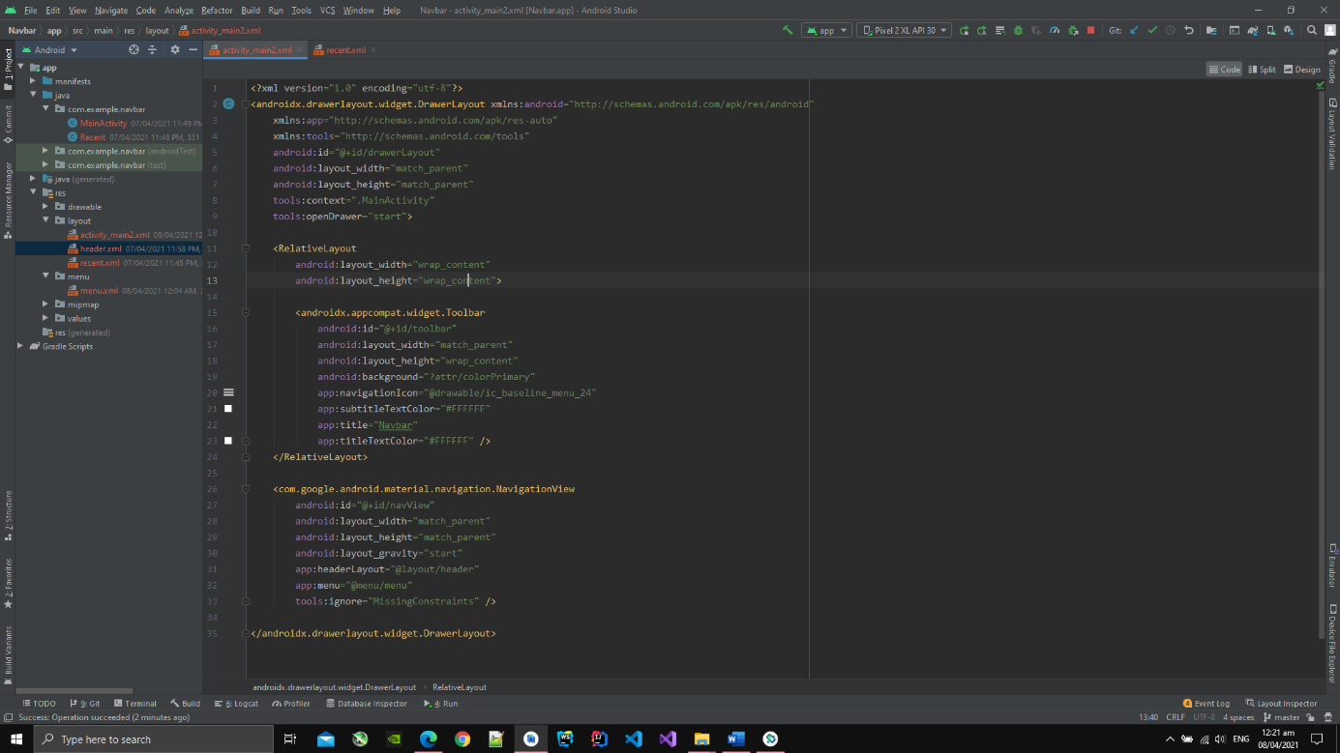

1. Afer clicking the options in navigation view, then screen switches to that activity
2. I have clicked Recent Option and screen is changed to Recent.

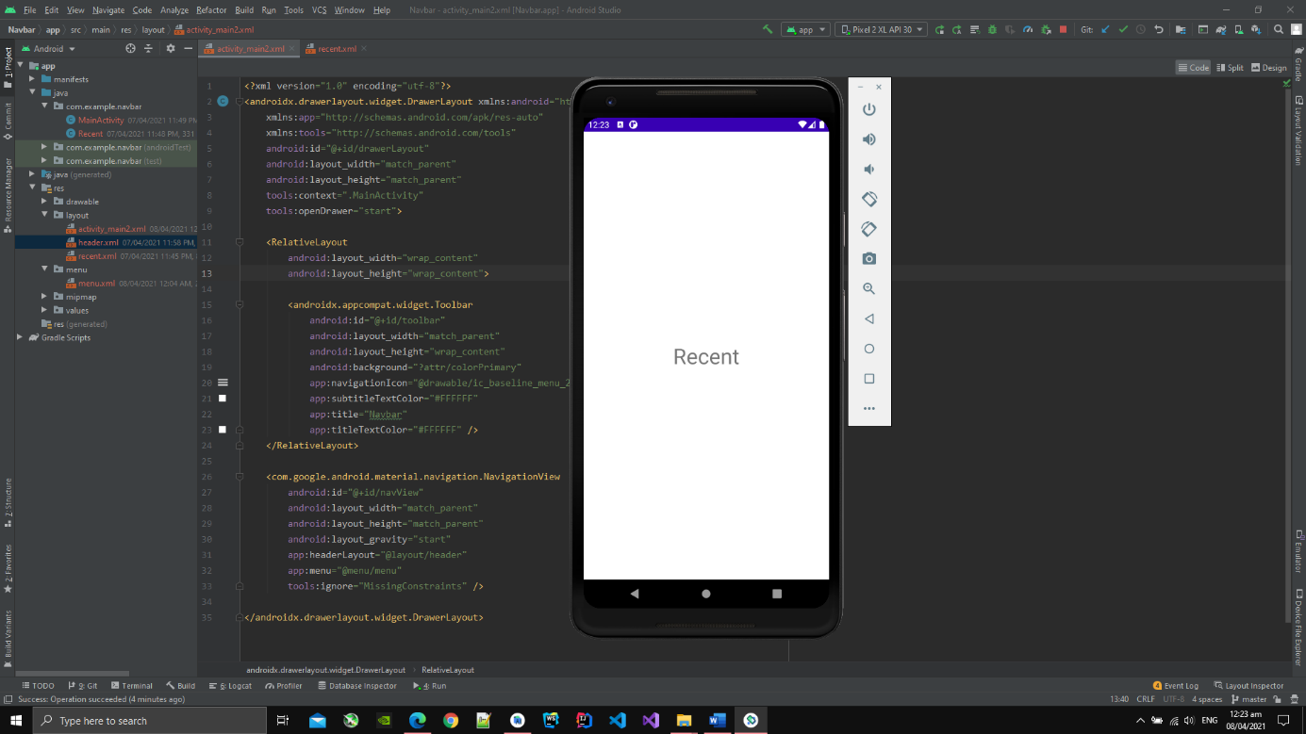

1. The java code for navigation view is given below:

